**INTRODUCTION**

My project name is CPU scheduling. It is a fundamental concept in operating system design that deals with determining the order in which processes are executed by the CPU. Since multiple processes may be in the ready queue simultaneously, the scheduler decides which one to run next. The main objective of CPU scheduling is to optimize CPU utilization, ensuring that the processor is used as efficiently as possible while minimizing the time processes spend waiting, improving throughput, and reducing turnaround and response times.

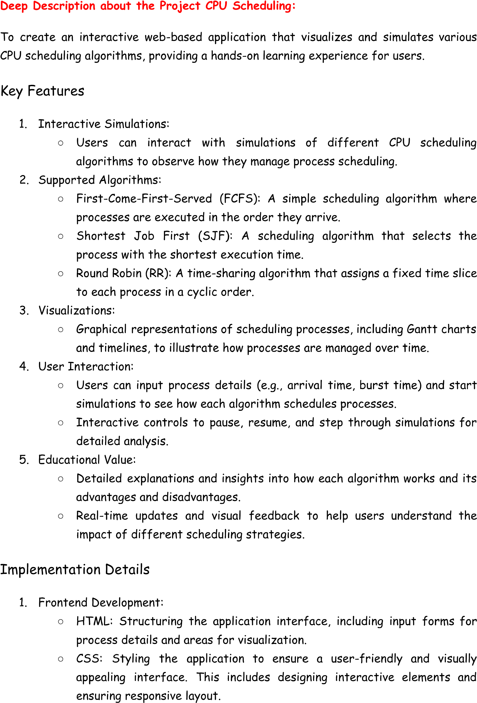

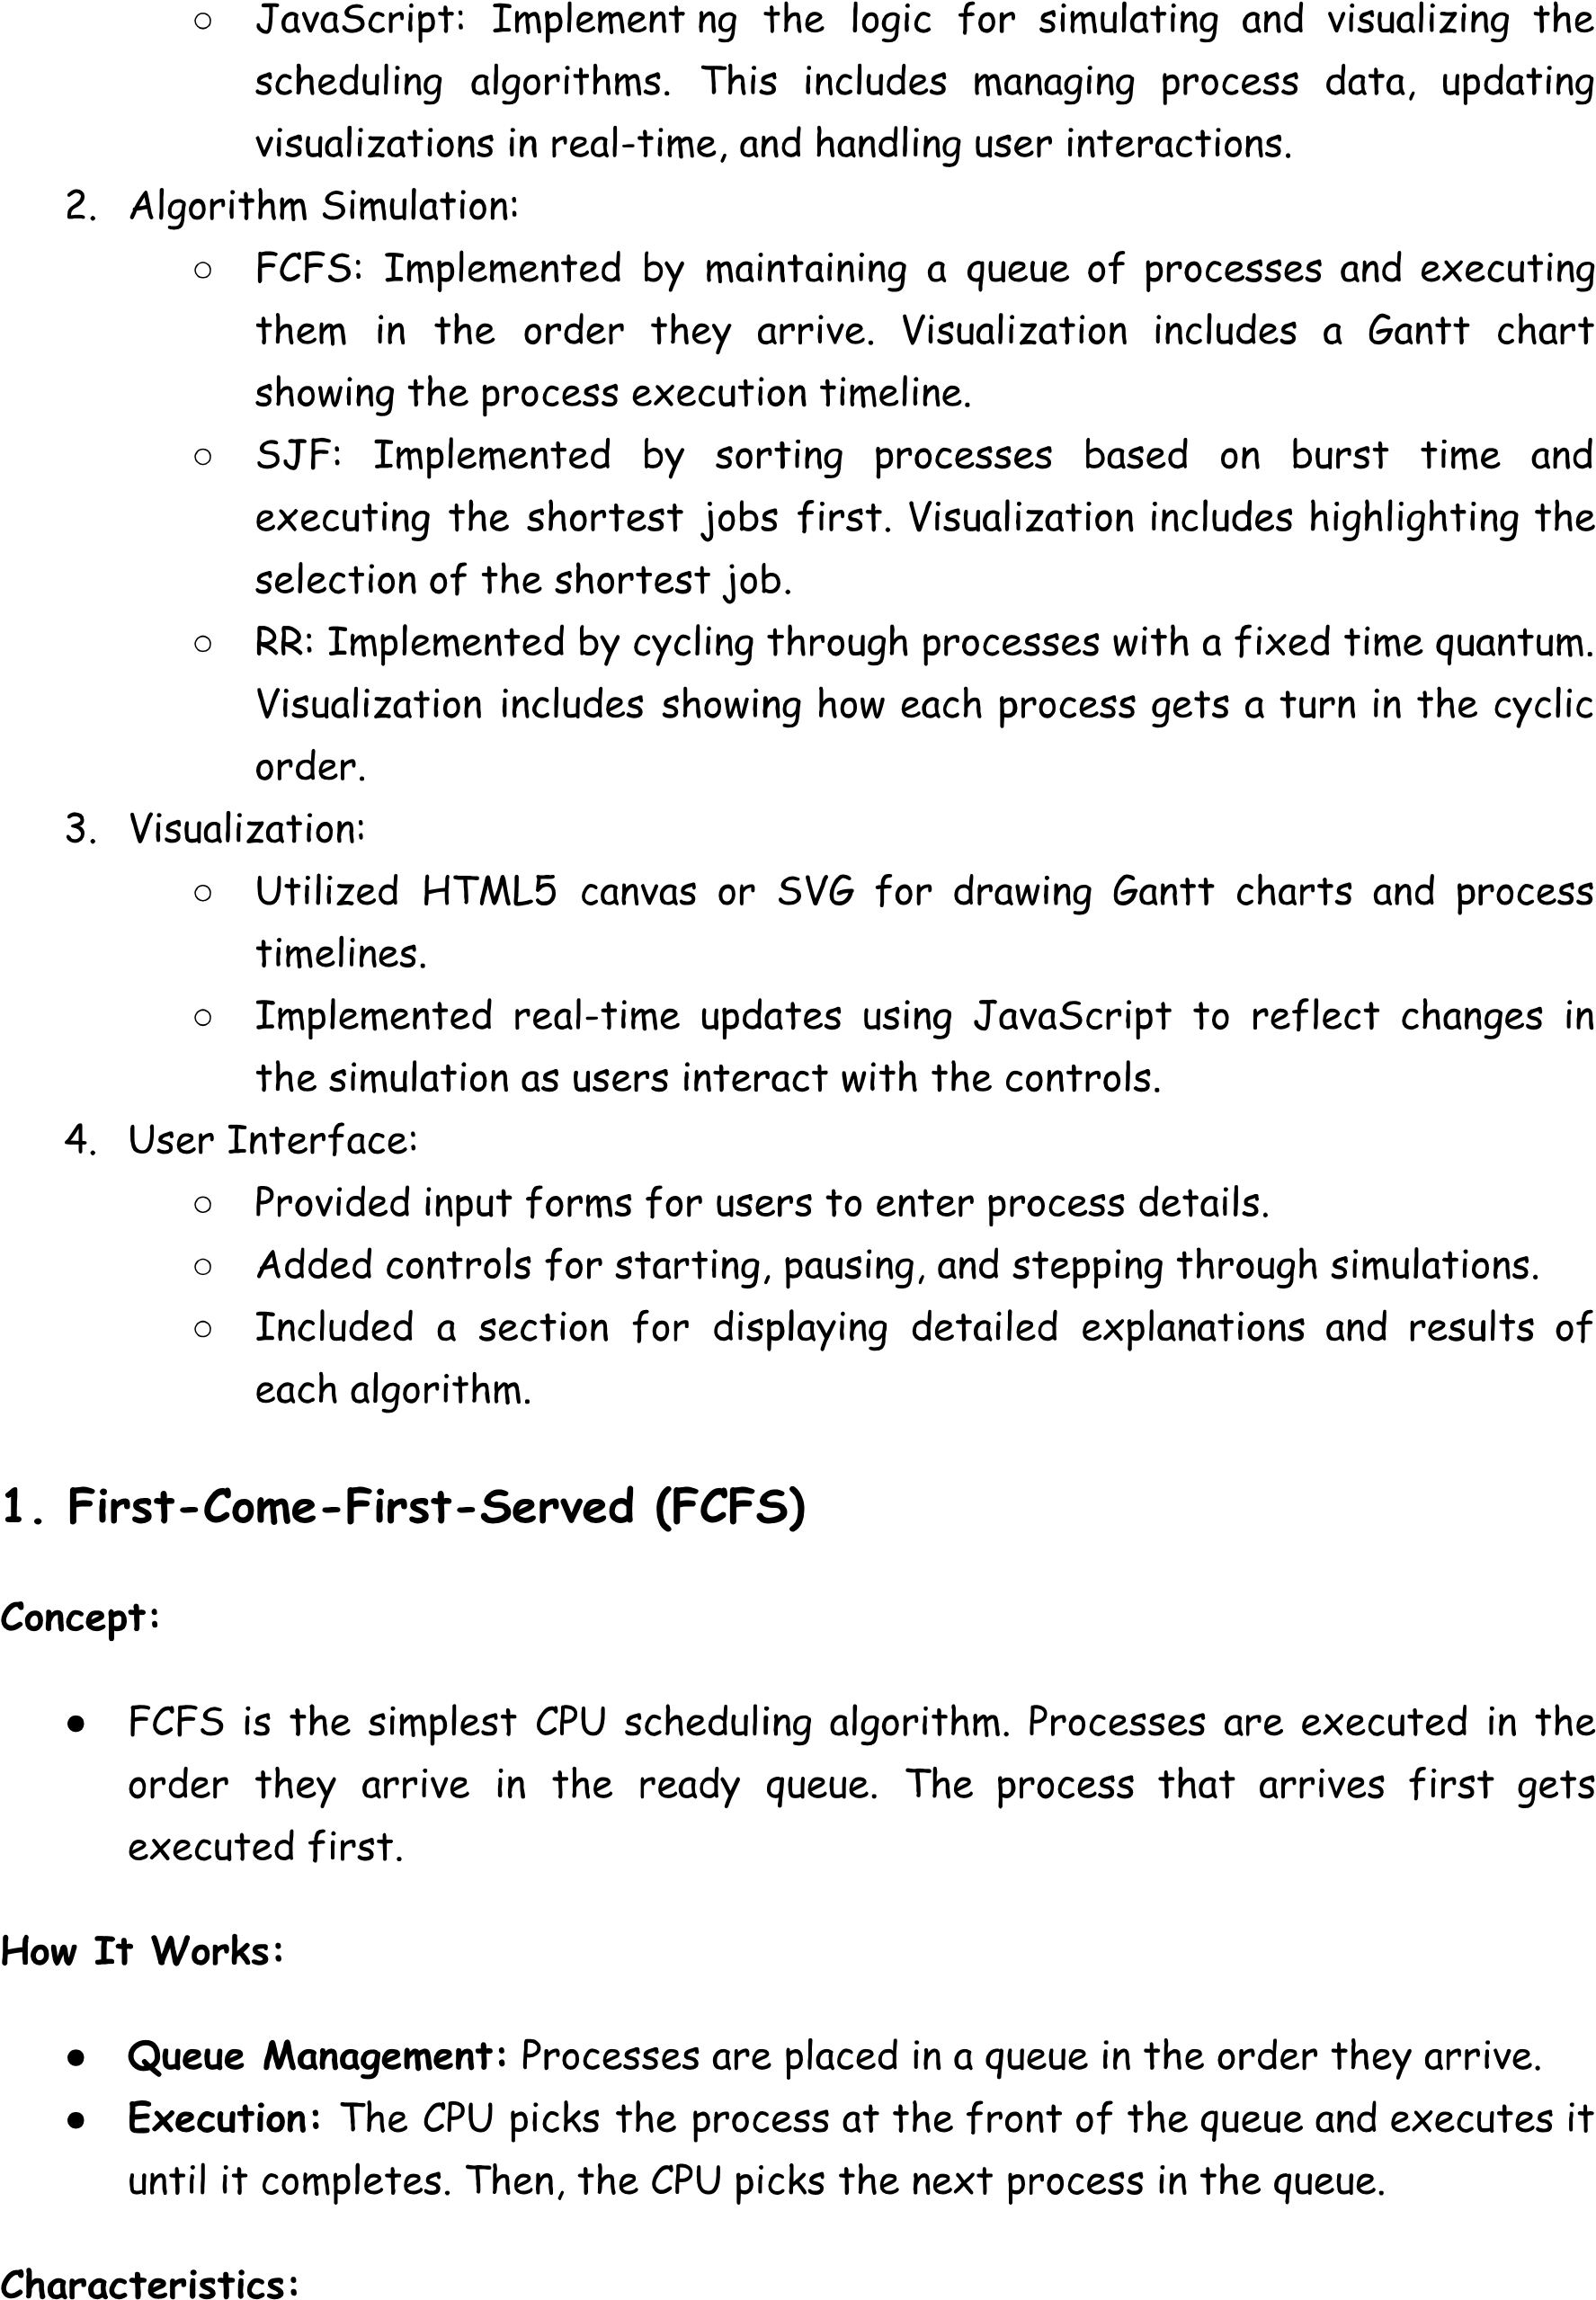

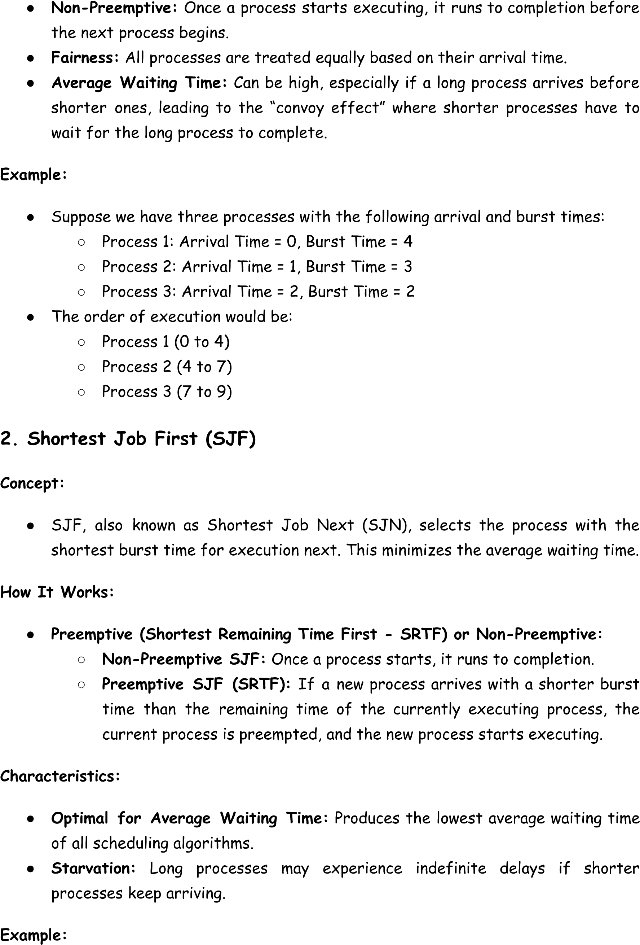

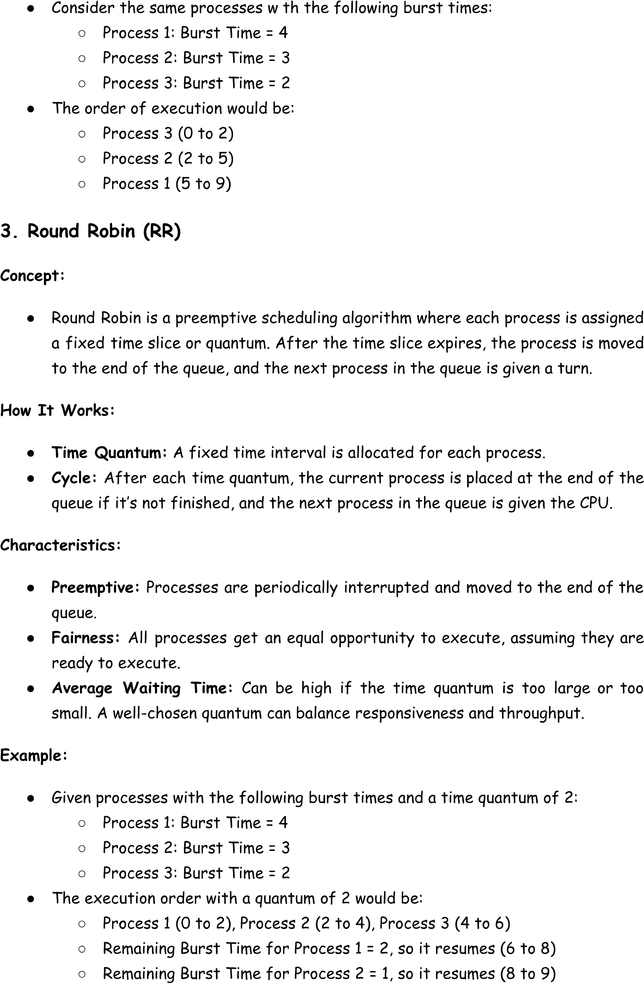

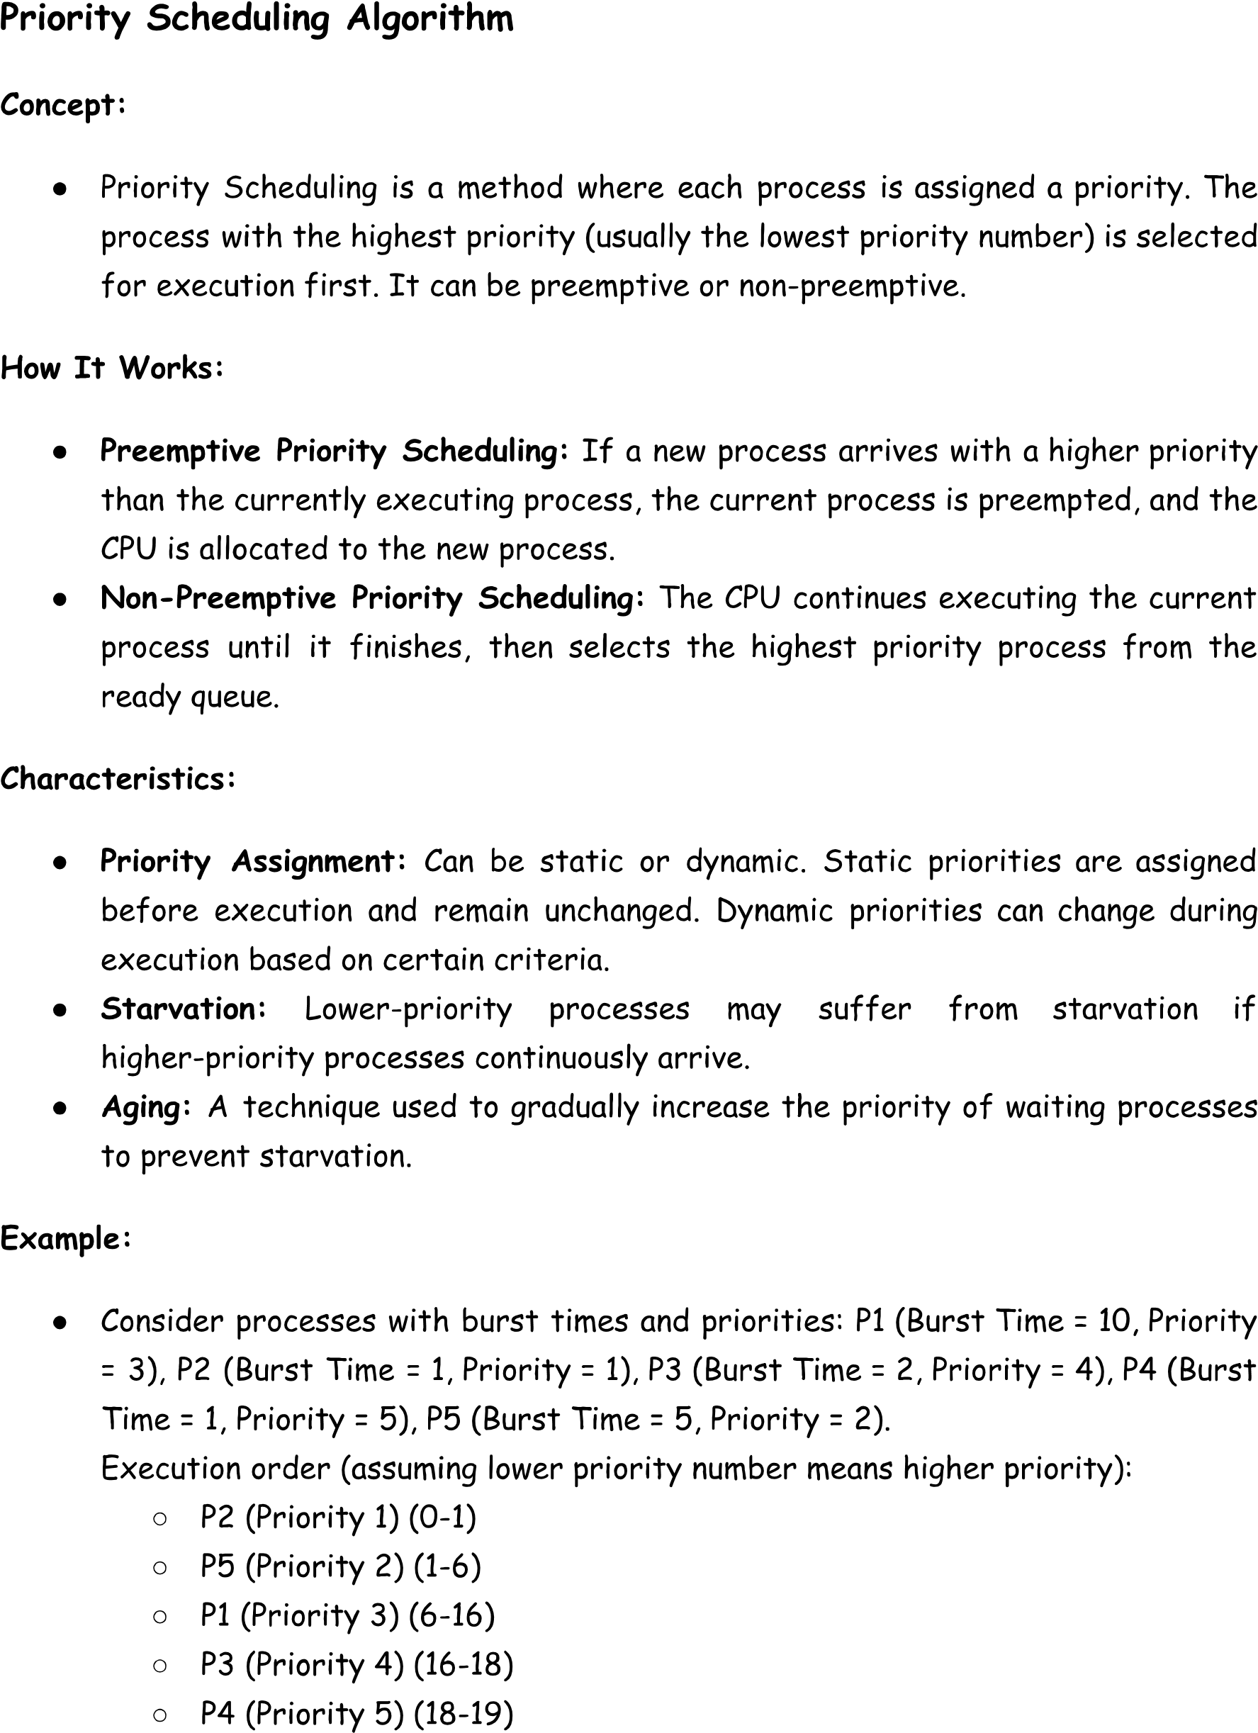

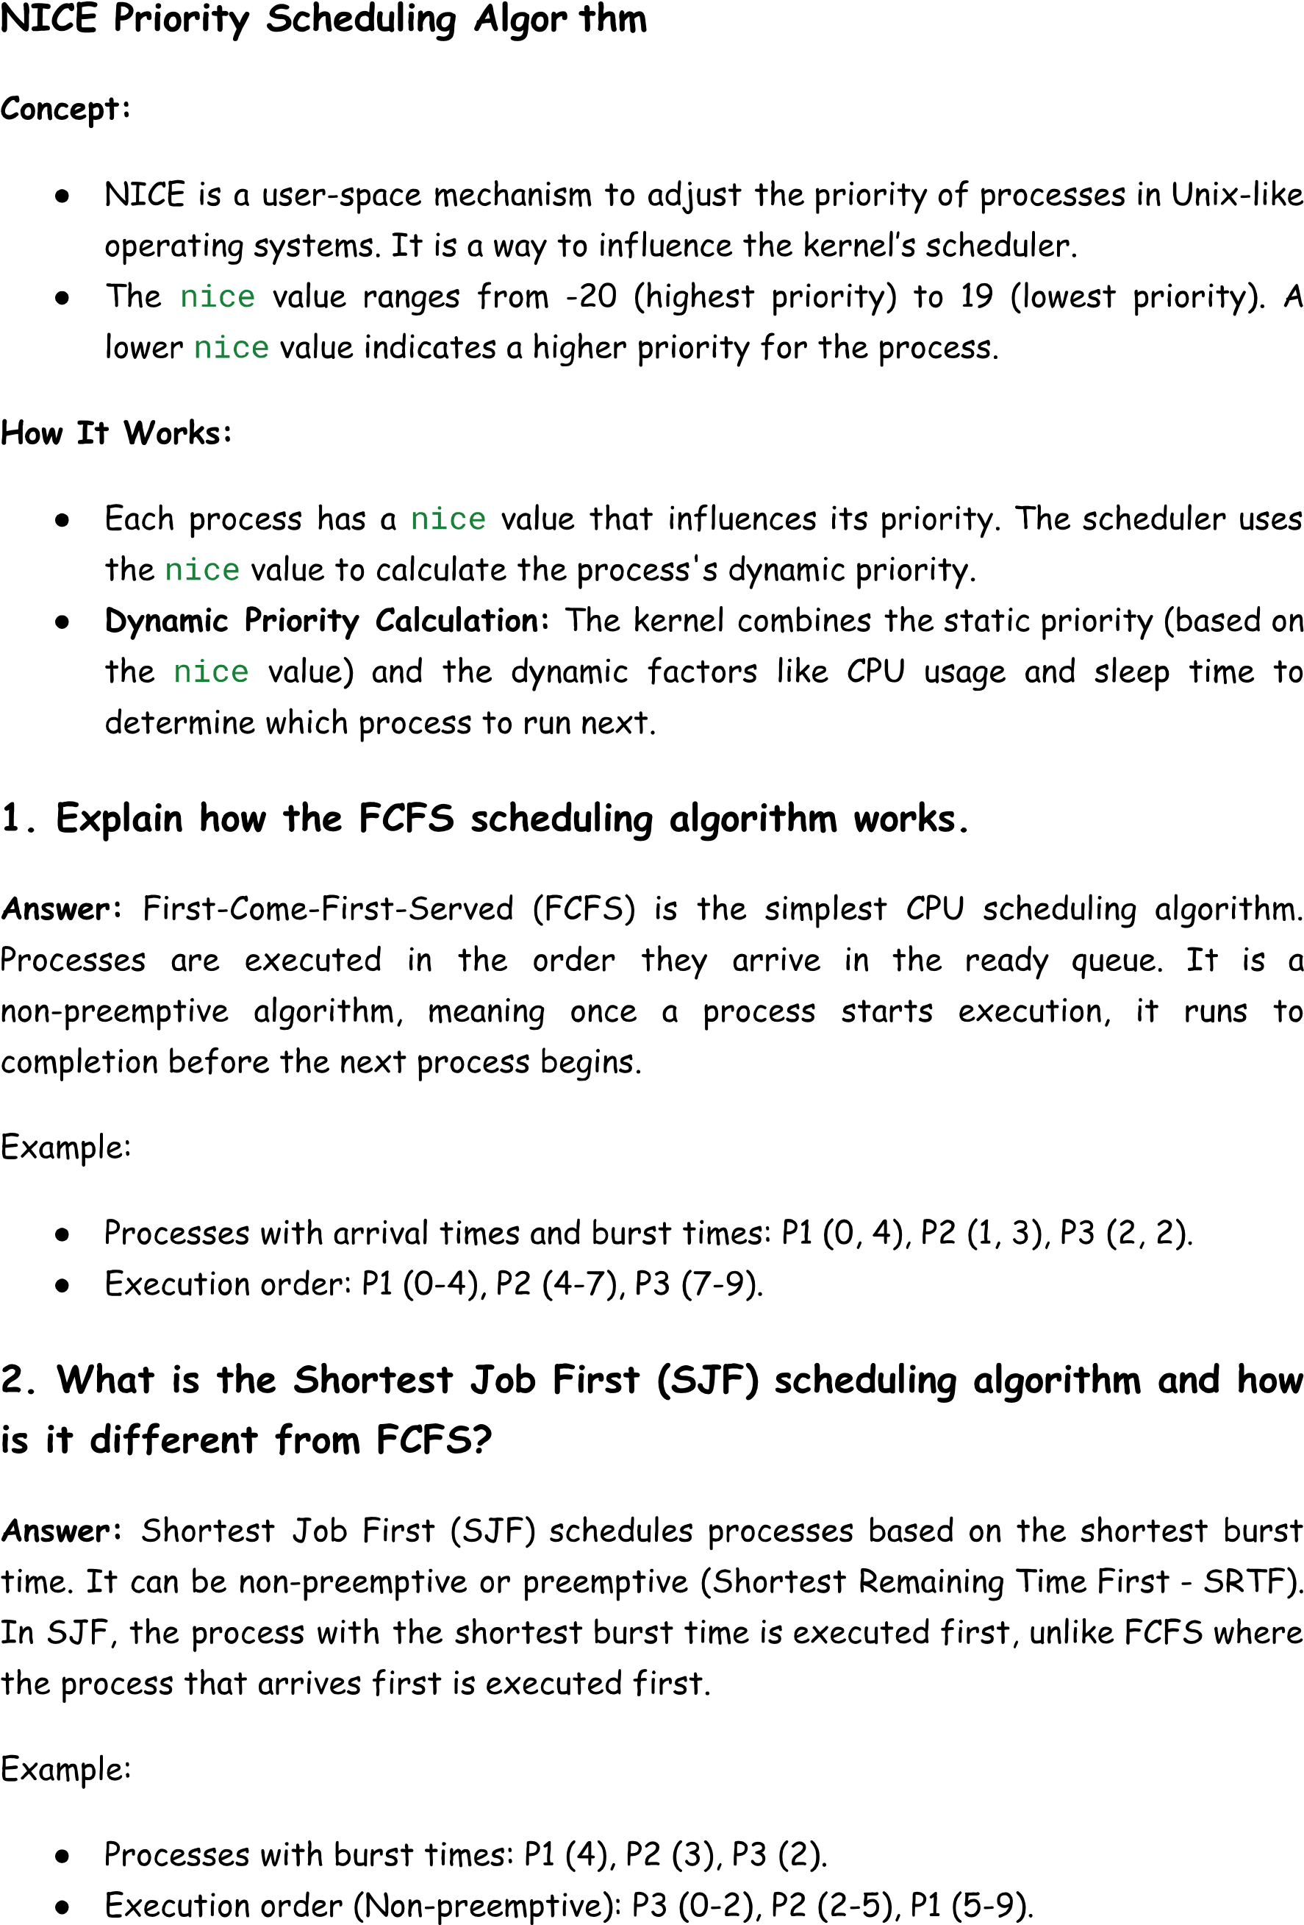

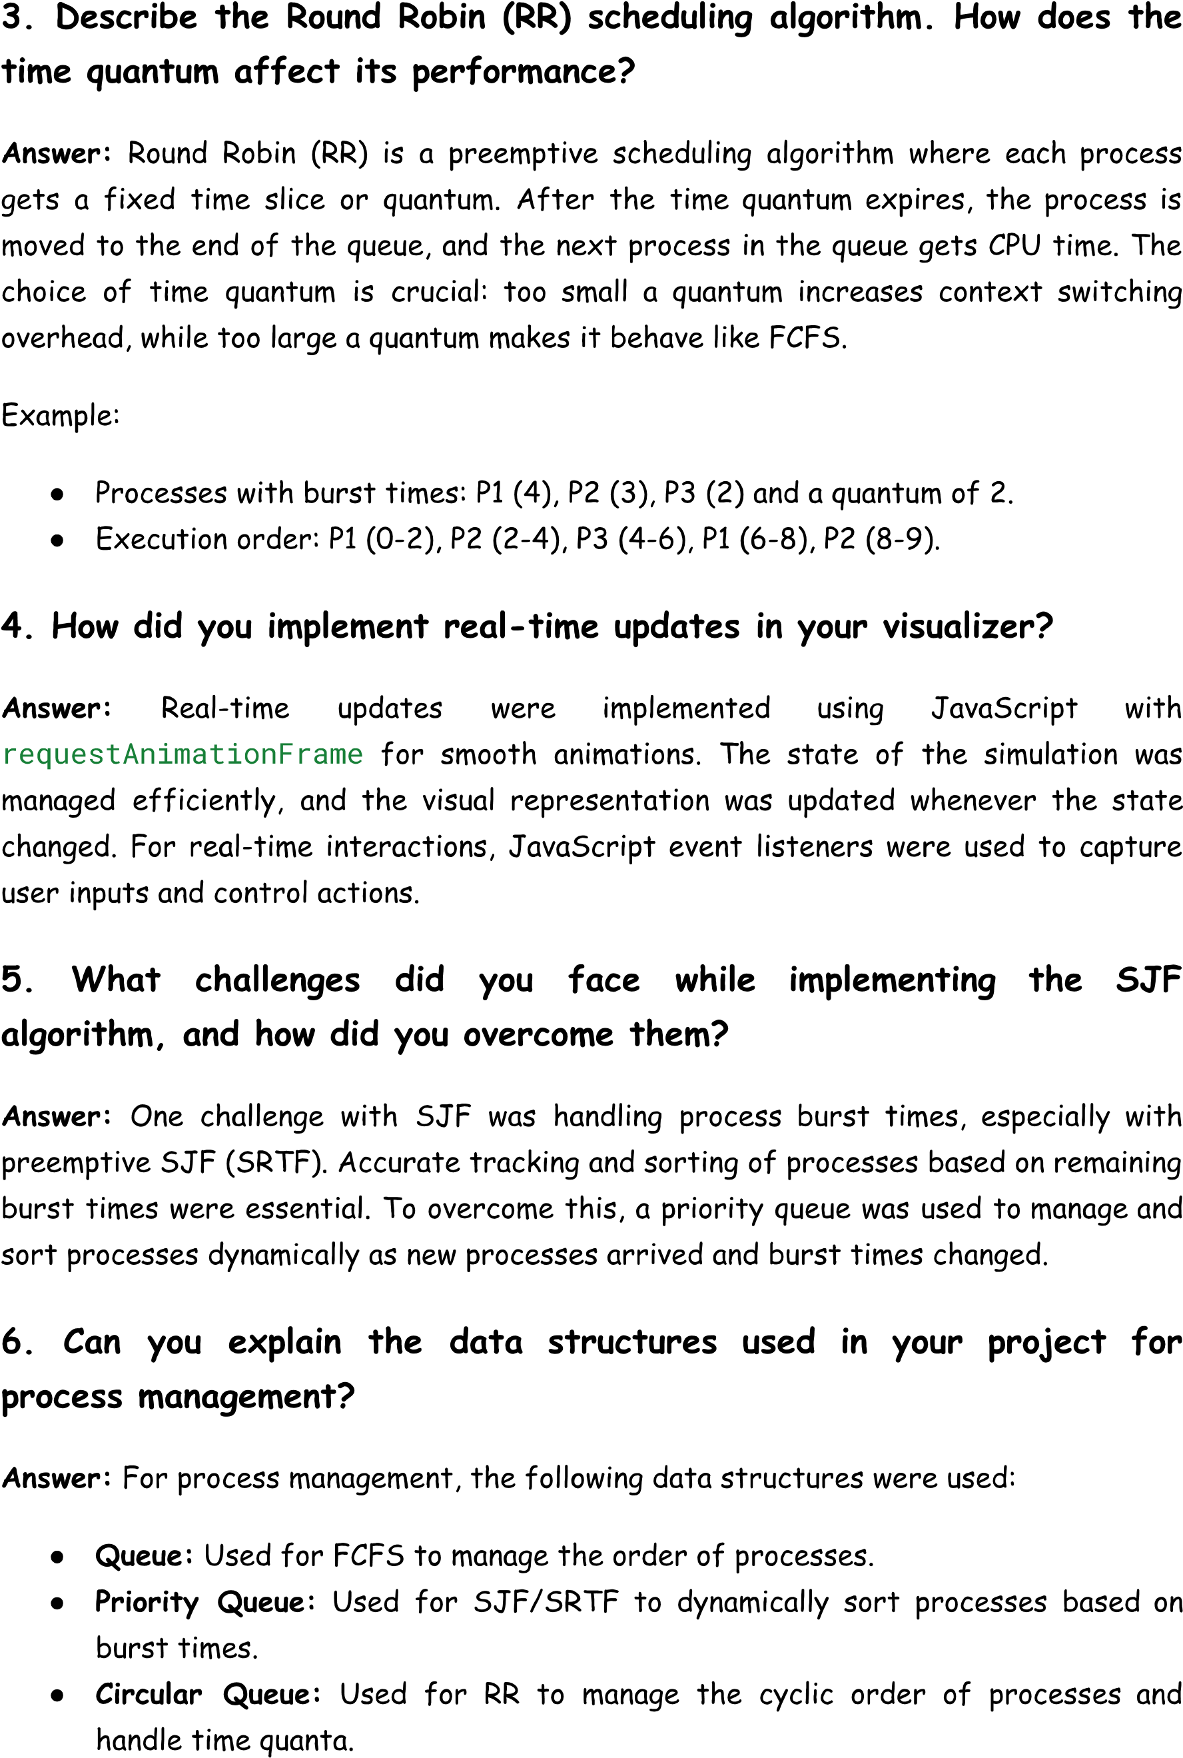

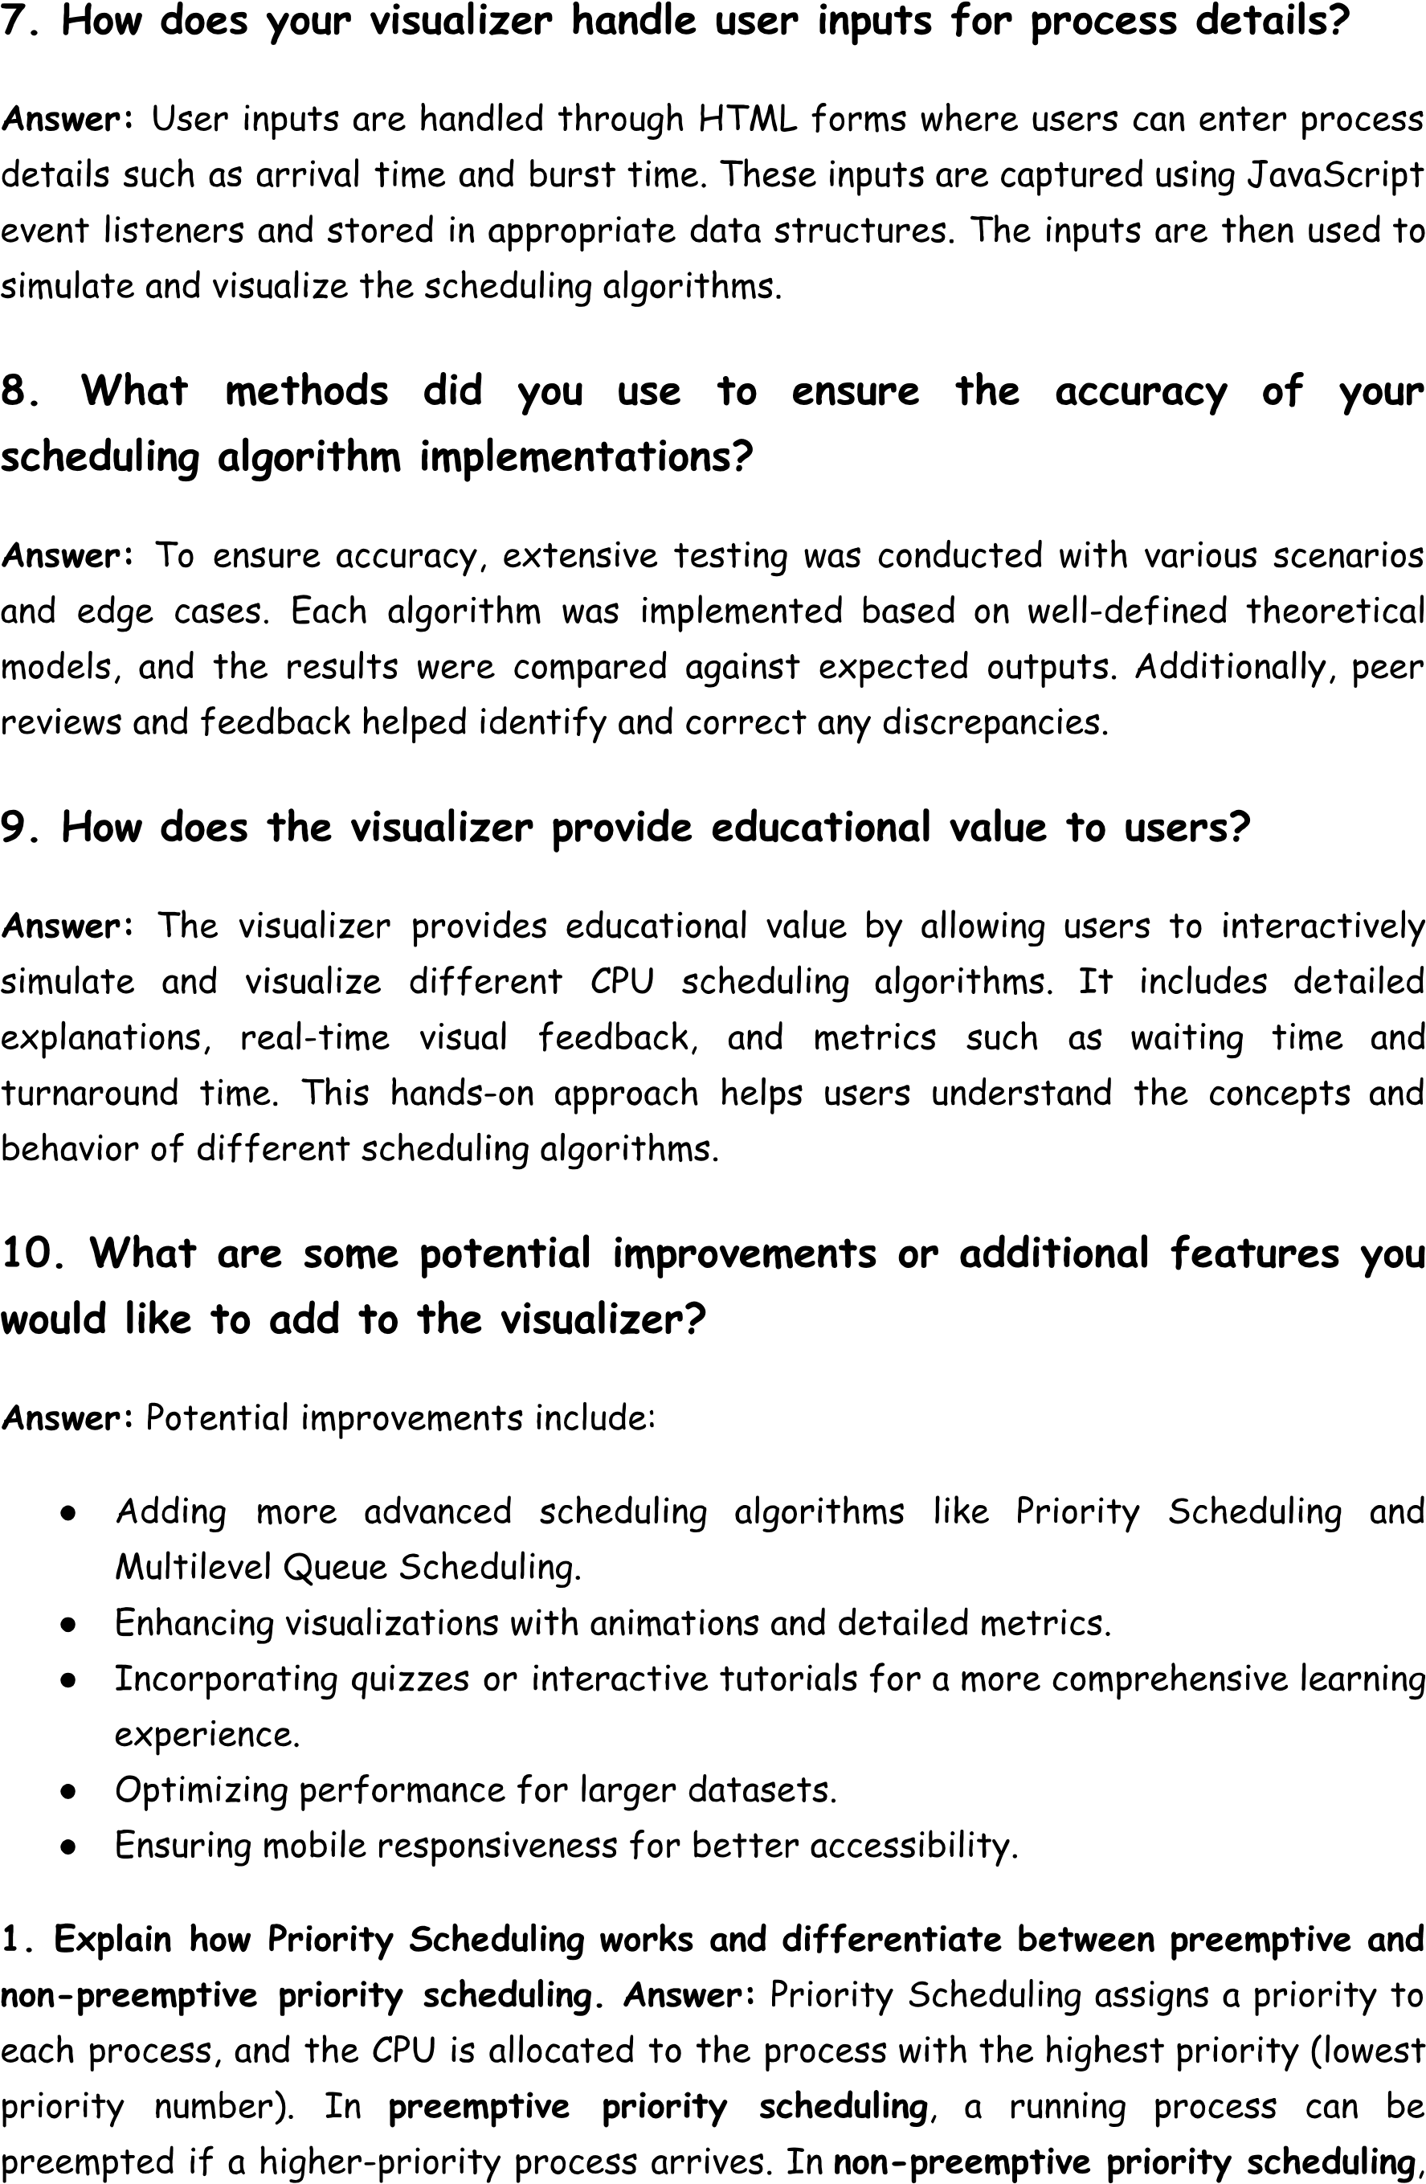

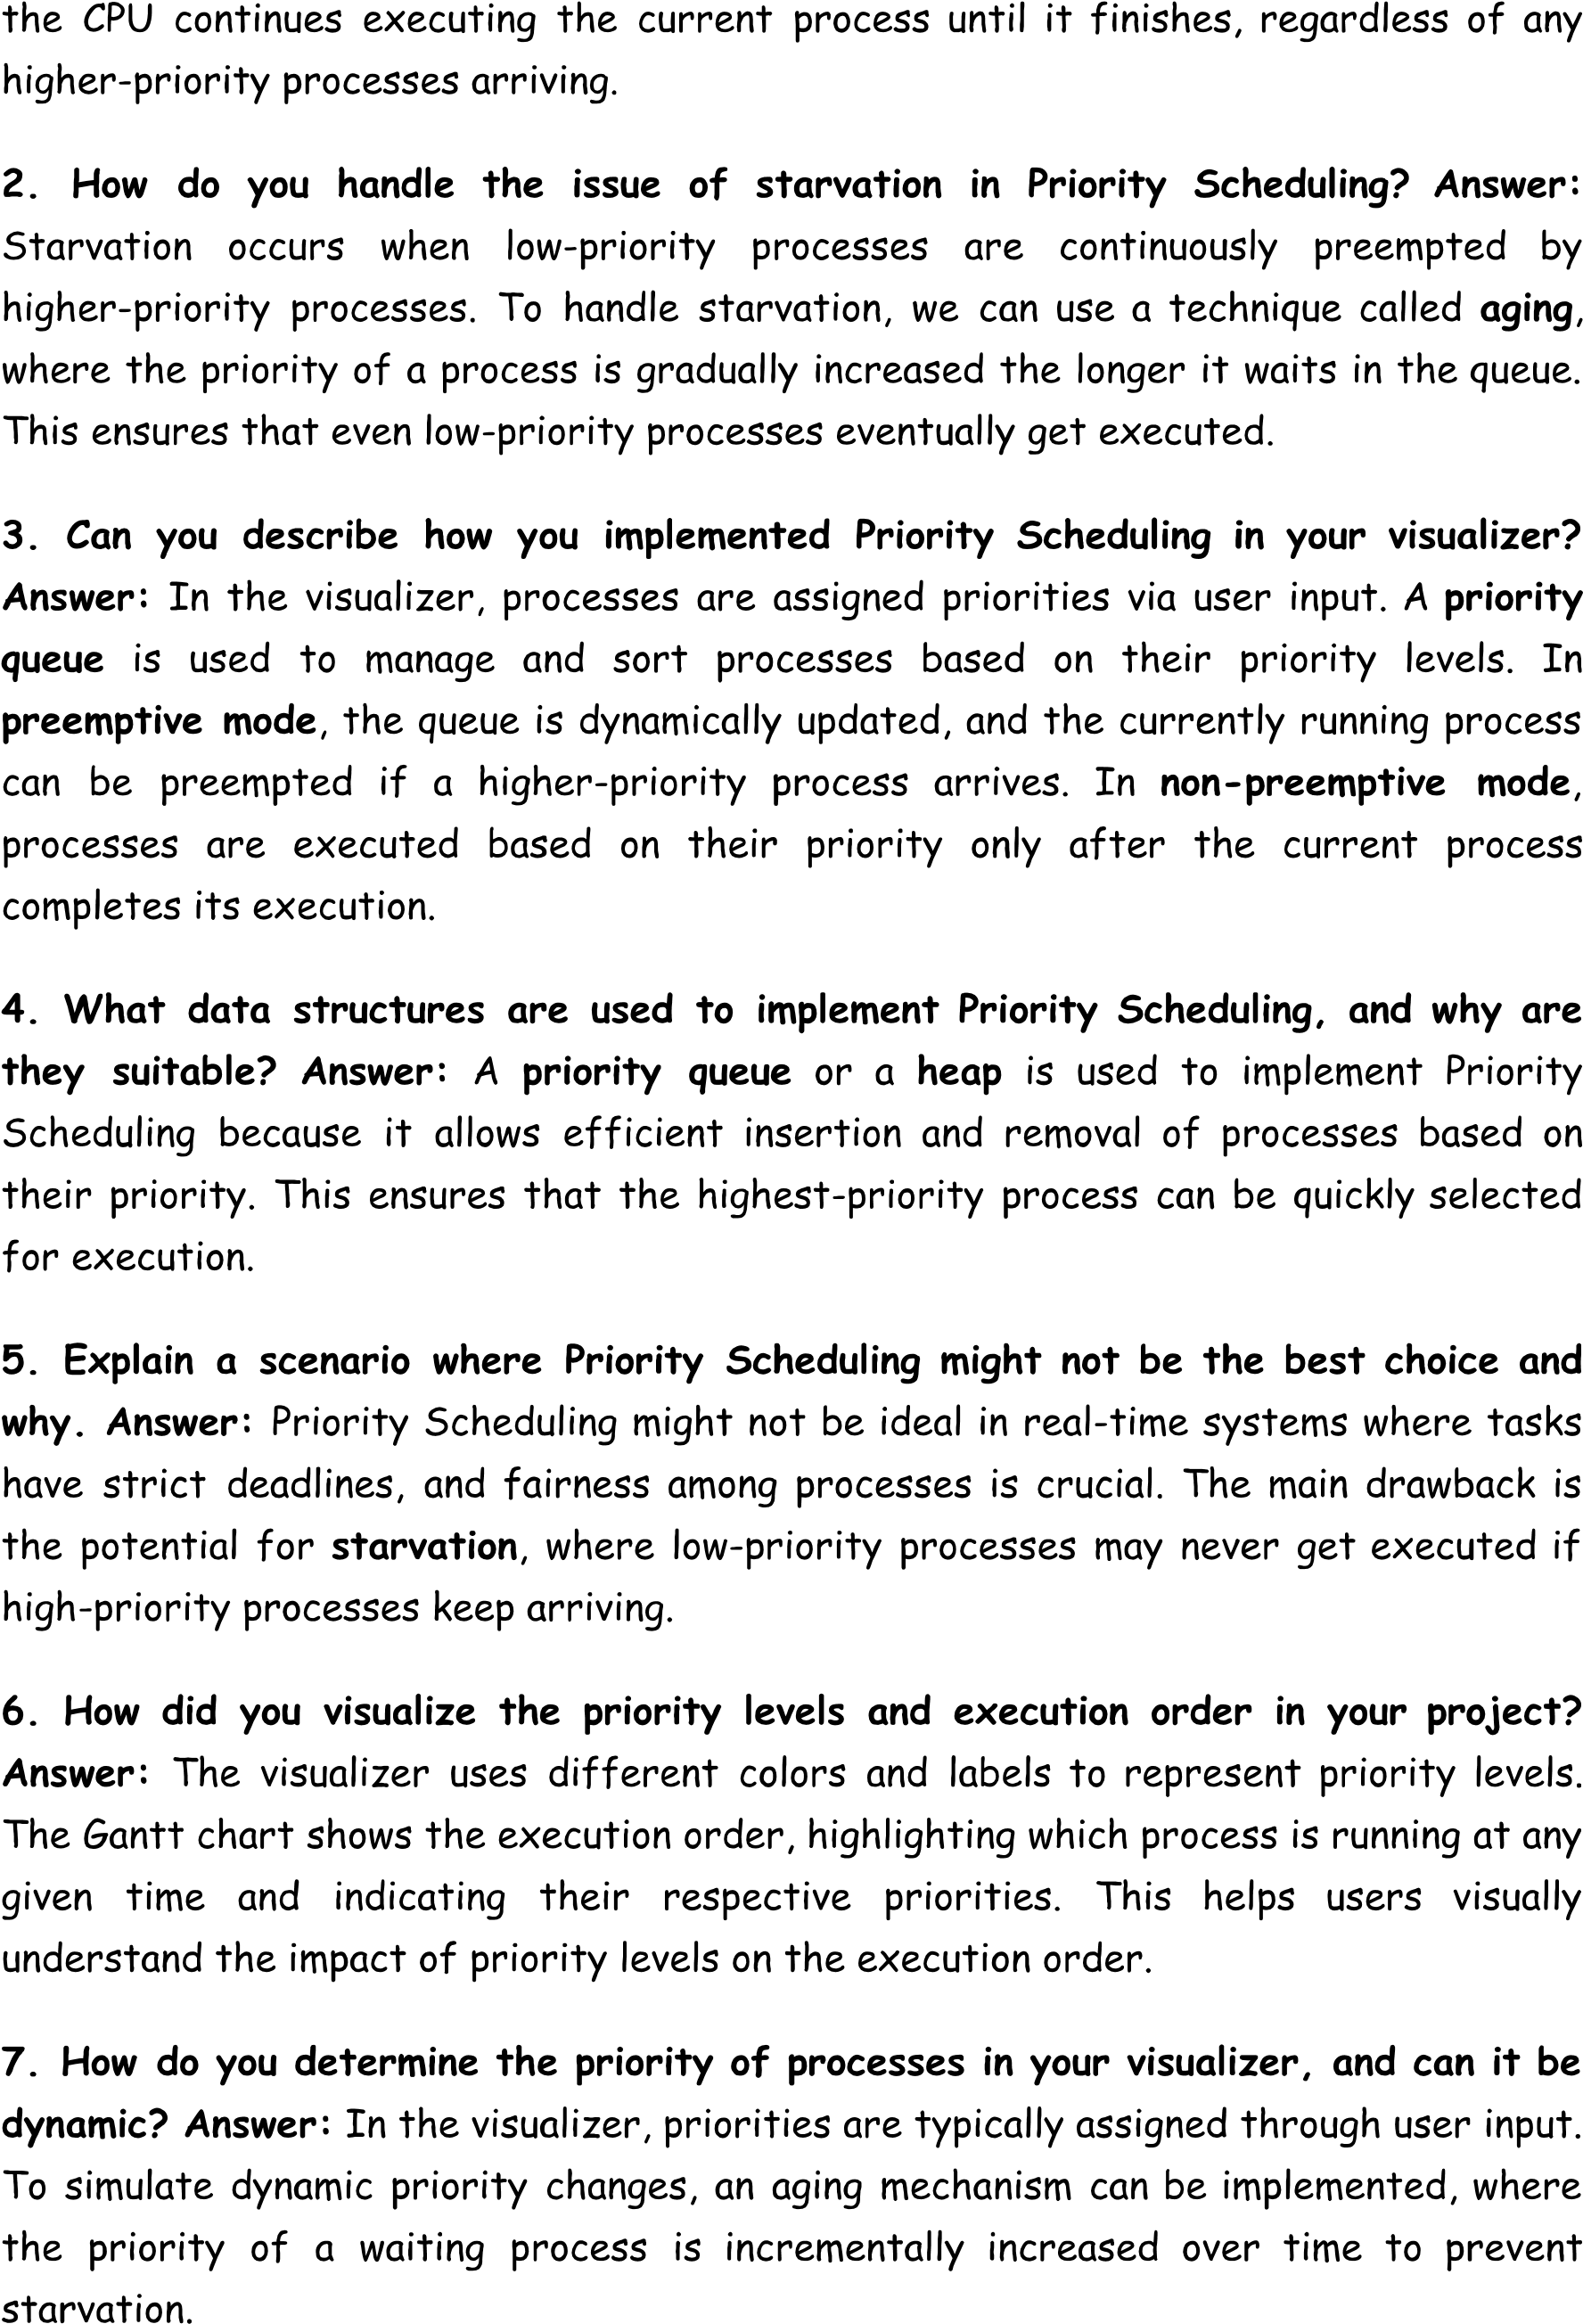

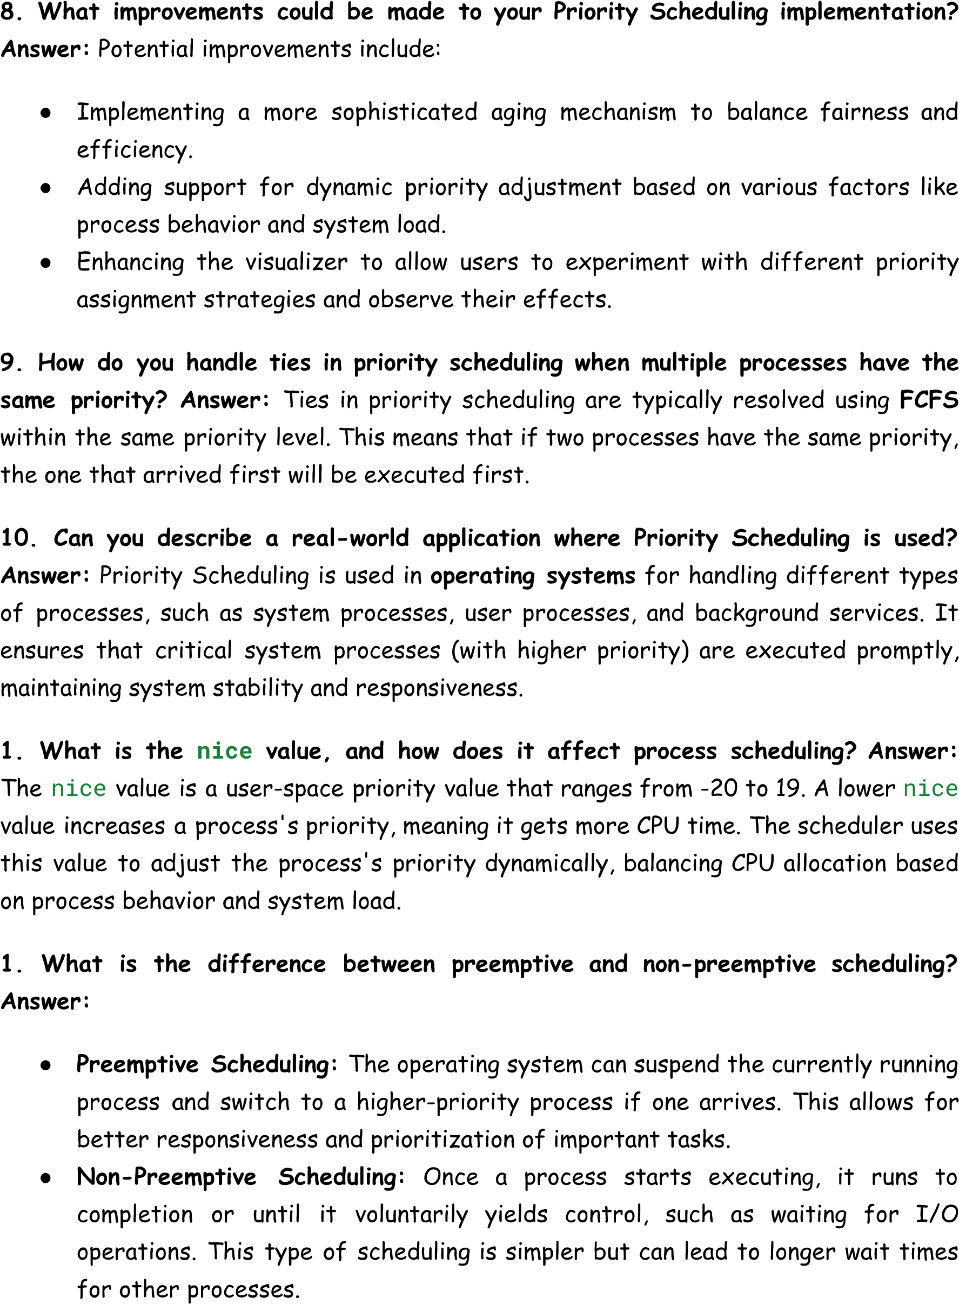

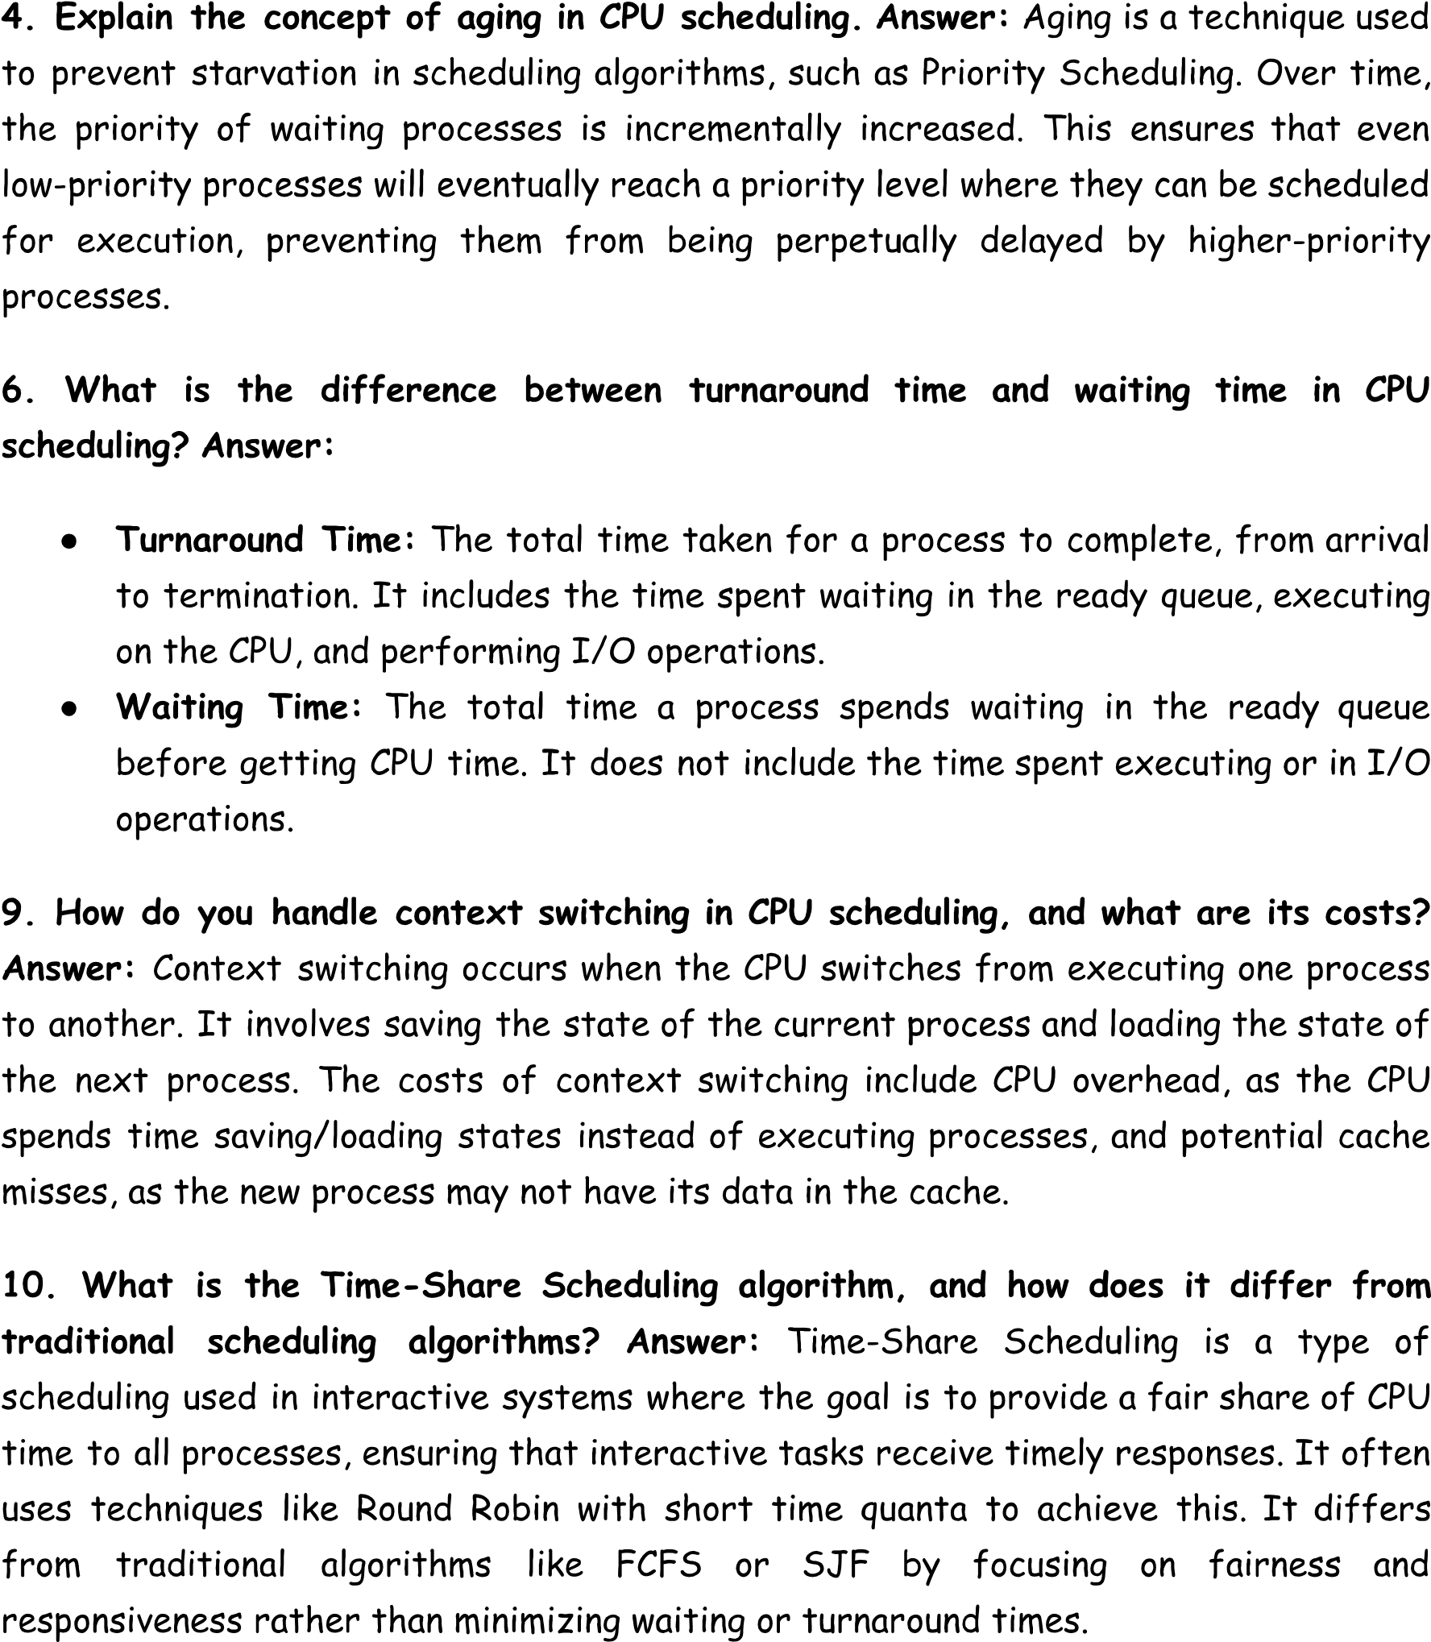

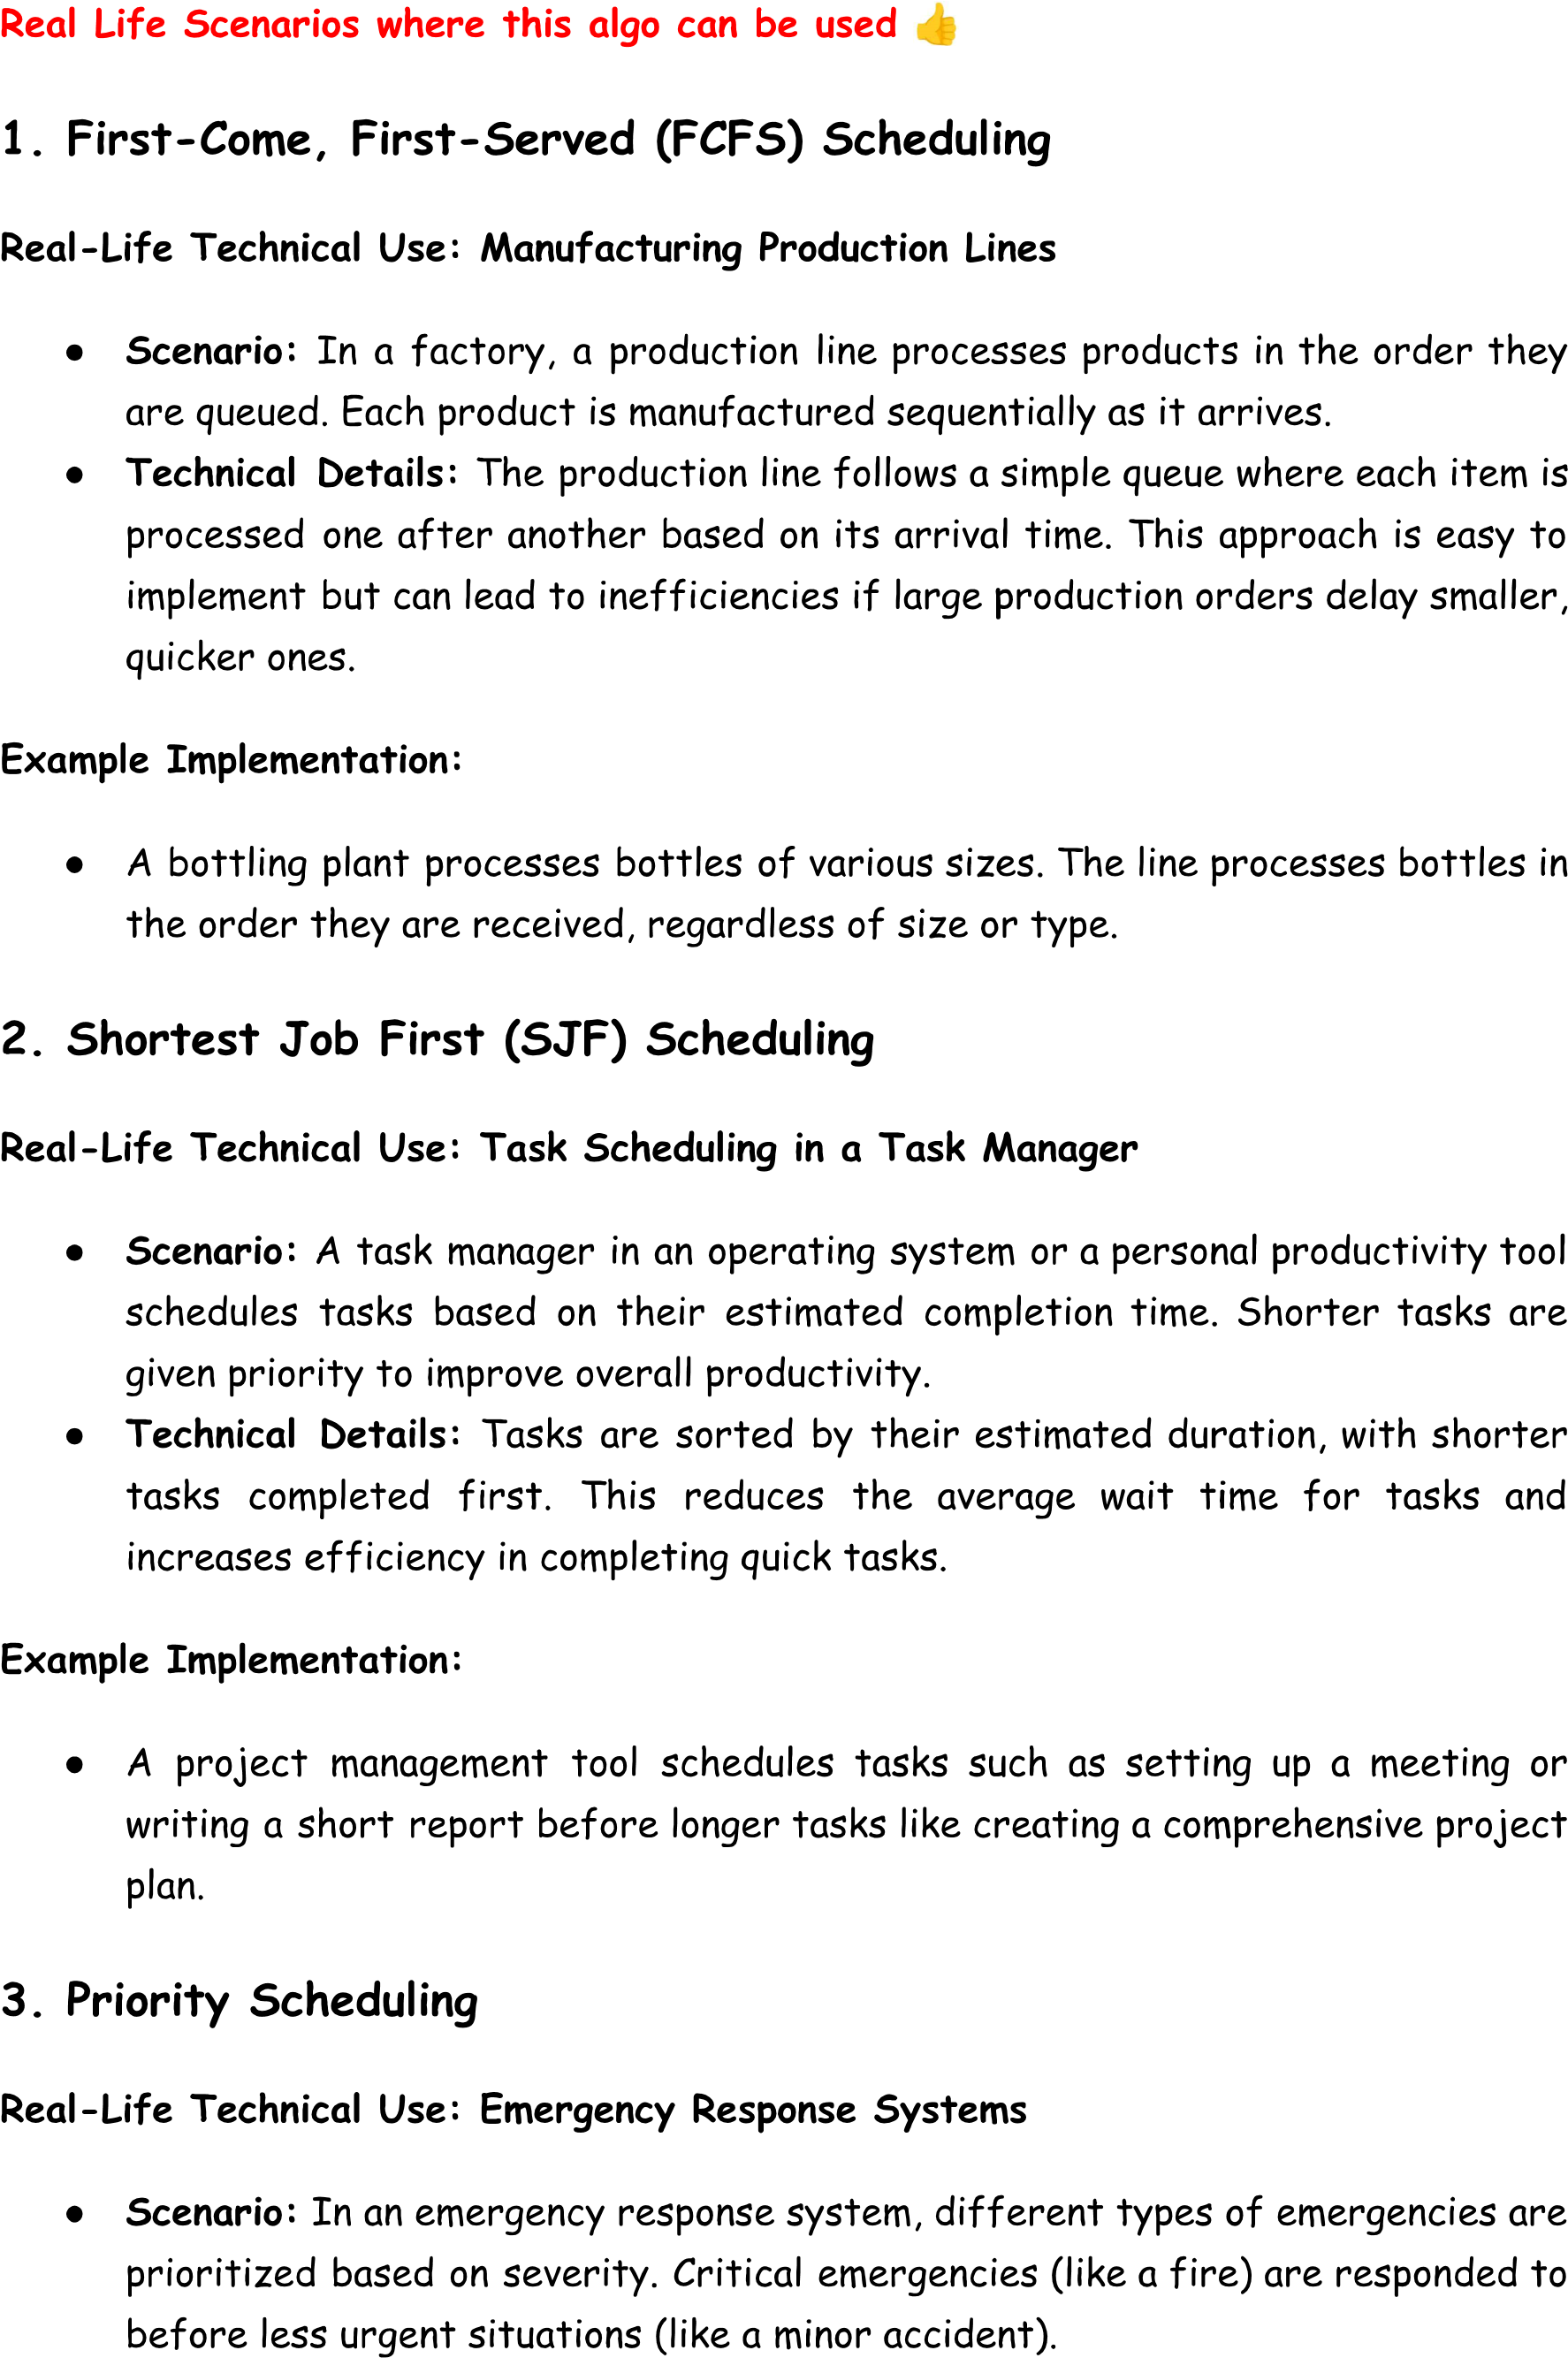

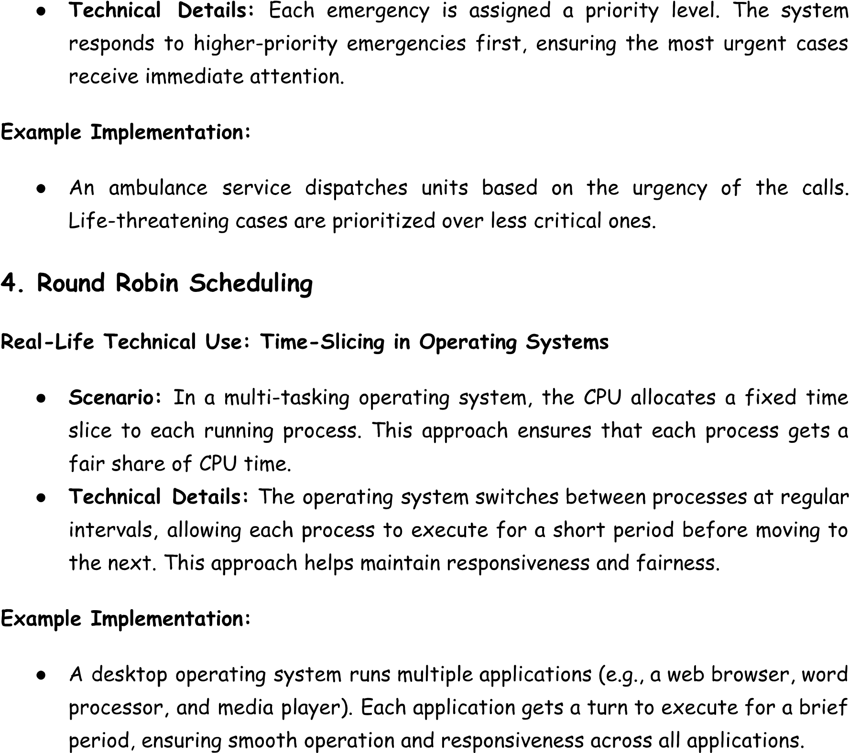

------------------------------------------------------------------------------------------------------------------------------------------------------------------------------------------*************---------------------------------------------------------------------------------------------------------------------------------------------------------------------------------------------

For your CPU scheduling project, here are potential interview questions that could be asked, along with detailed descriptions of the relevant code and scheduling algorithms used in your project. These questions focus on understanding the concepts, implementation, and code functionality related to scheduling algorithms like FCFS, SJF, and Round Robin.

**Questions & Answers:**

**1. What is CPU Scheduling, and why is it important?**

* **Answer:** CPU scheduling is the process of determining which processes will be assigned to the CPU for execution at any given time. It is essential for optimizing system performance, ensuring efficient utilization of CPU resources, and minimizing wait times for processes.

**2. What are the differences between First-Come-First-Served (FCFS), Shortest Job First (SJF), and Round Robin (RR) scheduling algorithms?**

* **Answer:**
  + **FCFS:** Processes are scheduled in the order they arrive, without priority. It is simple but can lead to the "convoy effect," where longer processes block shorter ones.
  + **SJF:** The process with the shortest burst time is executed next. It reduces average waiting time but requires knowledge of burst times, which may not always be available.
  + **RR:** Processes are scheduled in a cyclic order with a fixed time quantum. It ensures fairness and responsiveness but may lead to longer average turnaround time compared to SJF.

**3. Can you explain the implementation of the FCFS algorithm in your project?**

* **Answer:**
  + In your project, FCFS is implemented by sorting the processes based on their arrival times. The CPU is allocated to the first process that arrives, and subsequent processes are scheduled in the order they arrive.

javascript

Copy code

function fcfs(processes) {

let time = 0;

const ganttData = [];

processes.sort((a, b) => a.arrivalTime - b.arrivalTime); // Sort by arrival time

processes.forEach((proc) => {

if (time < proc.arrivalTime) {

time = proc.arrivalTime;

}

ganttData.push({ id: proc.id, start: time, end: time + proc.burstTime });

time += proc.burstTime;

});

return ganttData;

}

* + **Explanation:** Processes are sorted by their arrival time, and the Gantt chart data is generated by sequentially scheduling the processes based on their arrival and burst times.

**4. How is the SJF algorithm implemented in your project, and what is its advantage?**

* **Answer:**
  + The SJF algorithm is implemented by sorting processes based on burst time after they are sorted by arrival time. The process with the shortest burst time is scheduled next.

javascript

Copy code

function sjf(processes) {

let time = 0;

const ganttData = [];

const queue = [];

processes.sort((a, b) => a.arrivalTime - b.arrivalTime);

while (processes.length > 0 || queue.length > 0) {

while (processes.length > 0 && processes[0].arrivalTime <= time) {

queue.push(processes.shift());

}

if (queue.length > 0) {

queue.sort((a, b) => a.burstTime - b.burstTime);

const proc = queue.shift();

ganttData.push({ id: proc.id, start: time, end: time + proc.burstTime });

time += proc.burstTime;

} else {

time++;

}

}

return ganttData;

}

* + **Explanation:** This non-preemptive SJF implementation selects the job with the shortest burst time from the queue. If no job is available, it increments the time until a process arrives.

**5. Can you describe the Round Robin algorithm and its implementation?**

* **Answer:**
  + Round Robin scheduling cycles through processes in the order they arrive, giving each process a fixed time quantum.

javascript

Copy code

function roundRobin(processes, quantum) {

let time = 0;

const queue = [];

const ganttData = [];

const remainingBurstTimes = {};

let detailedResult = 'Round Robin Scheduling:\n';

processes.forEach(proc => remainingBurstTimes[proc.id] = proc.burstTime);

processes.sort((a, b) => a.arrivalTime - b.arrivalTime);

while (processes.length > 0 || queue.length > 0) {

while (processes.length > 0 && processes[0].arrivalTime <= time) {

queue.push(processes.shift());

}

if (queue.length > 0) {

const proc = queue.shift();

const burst = Math.min(quantum, remainingBurstTimes[proc.id]);

ganttData.push({ id: proc.id, start: time, end: time + burst });

detailedResult += `Process ${proc.id} runs from ${time} to ${time + burst}.\n`;

time += burst;

remainingBurstTimes[proc.id] -= burst;

if (remainingBurstTimes[proc.id] > 0) {

queue.push(proc);

} else {

detailedResult += `Process ${proc.id} finishes at ${time}.\n`;

}

} else {

time++;

}

}

return ganttData;

}

* + **Explanation:** Processes are scheduled cyclically based on the time quantum. If a process does not finish within the time quantum, it is placed back in the queue.

**6. What is a Gantt chart, and how is it used in your project?**

* **Answer:**
  + A Gantt chart is a visual representation of the scheduling timeline, showing when each process starts and ends. In your project, the Gantt chart is drawn using the canvas element, displaying the CPU usage over time for each scheduling algorithm.

javascript

Copy code

function drawGanttChart(ganttData) {

const chartWidth = ganttCanvas.width;

const chartHeight = ganttCanvas.height;

const totalDuration = ganttData[ganttData.length - 1].end;

const unitWidth = chartWidth / totalDuration;

ganttCtx.clearRect(0, 0, chartWidth, chartHeight);

ganttData.forEach((block, index) => {

const startX = block.start * unitWidth;

const blockWidth = (block.end - block.start) * unitWidth;

ganttCtx.fillStyle = `hsl(${index * 90}, 70%, 50%)`;

ganttCtx.fillRect(startX, 50, blockWidth, 50);

ganttCtx.fillStyle = 'white';

ganttCtx.font = "16px Arial";

ganttCtx.fillText(block.id, startX + blockWidth / 2 - 10, 80);

ganttCtx.fillText(block.start, startX, 110);

ganttCtx.fillText(block.end, startX + blockWidth - 10, 110);

});

}

* + **Explanation:** The chart uses colored blocks to represent each process. The length of the block is proportional to the process’s burst time.

**7. How do you handle input validation for the CPU scheduling simulation?**

* **Answer:** Input validation is essential for ensuring correct data. In your project, processes are added through a form, and the input values (Process ID, Arrival Time, Burst Time) are checked to ensure they are valid before starting the simulation.

**8. Can you explain how the CSS is used to style the project?**

* **Answer:**
  + The project uses a dark theme with responsive layouts for various screen sizes. Key styles include:

css

Copy code

body {

background-color: #121212;

display: flex;

justify-content: center;

align-items: center;

min-height: 100vh;

padding: 20px;

}

.container {

background-color: #1e1e1e;

border-radius: 12px;

padding: 30px;

box-shadow: 0 4px 12px rgba(0, 0, 0, 0.7);

}

* + **Explanation:** The styles focus on making the interface visually appealing with a clean, modern look, using flexbox for layout and CSS animations for smooth transitions.

**Additional Questions:**

* **9. How do you handle process priorities if implemented in your project?**
* **10. Can you explain the use of event listeners in the app.js file?**
* **11. What would you change if you wanted to simulate preemptive scheduling in SJF?**

These questions explore key aspects of your CPU scheduling project, from the theoretical foundation of algorithms to their practical implementation and the code's functionality.

4o

**You said:**

How to test scalability?

**ChatGPT said:**

ChatGPT

Testing the **scalability** of a web-based project, like your CPU scheduling simulator, involves evaluating how well the system performs under increasing loads (e.g., more users, processes, or data). The goal is to determine whether the system can handle growth effectively without significant drops in performance, crashes, or other issues. Here’s a detailed guide on how to test scalability:

**1. Load Testing**

Load testing evaluates how your system behaves under normal and peak loads. For your CPU scheduling simulator, you could simulate numerous concurrent users or processes being added.

* **Tools**:
  + **JMeter**: An open-source load testing tool for measuring performance under different loads.
  + **Locust**: Python-based tool for simulating user load and testing the system's performance.
  + **Apache Benchmark (AB)**: A simple tool to benchmark the performance of web applications.
* **Example Scenario**:
  + Simulate 1,000 users using the scheduling app simultaneously.
  + Add different numbers of processes to the simulator and observe if it slows down.
* **Metrics to track**:
  + Response time: How long it takes for the application to process the request.
  + Throughput: The number of requests handled in a specific time period.
  + Error rate: The percentage of failed or timed-out requests.

**2. Stress Testing**

Stress testing pushes the system beyond its normal load to identify its breaking point or critical failure areas. This helps in understanding how the system recovers after hitting extreme loads.

* **Steps**:
  + Start with a normal load and gradually increase the number of users, processes, or data until the system fails or slows dramatically.
  + Monitor resource usage (CPU, memory) during the test.
* **Example in Your Project**:
  + Continuously add processes to the scheduling simulator beyond expected limits to see if the simulation can handle large numbers.
  + Check if the Gantt chart renders and processes properly when overloaded with hundreds or thousands of entries.

**3. Performance Profiling**

Performance profiling involves identifying bottlenecks in the code or infrastructure that prevent the system from scaling effectively. You can profile different parts of the app, such as scheduling algorithms (FCFS, SJF, Round Robin), the Gantt chart rendering, or database queries (if applicable).

* **Tools**:
  + **Chrome DevTools**: For front-end profiling (JavaScript execution time, rendering issues).
  + **Node.js Profiling Tools**: For back-end profiling, such as clinic.js or 0x for analyzing CPU and memory usage in Node.js apps.
* **Metrics to track**:
  + Time taken by different scheduling algorithms.
  + JavaScript execution time during Gantt chart rendering.
  + CPU and memory usage for large process lists.

**4. Horizontal and Vertical Scalability Testing**

* **Horizontal Scalability**: Involves testing if the application can scale by adding more servers or instances (distributed across multiple machines).
  + **Approach**: Use tools like **Docker** or **Kubernetes** to run the application on multiple instances and test how well it handles balancing user load across instances.
* **Vertical Scalability**: Involves testing the system by adding more resources (CPU, memory) to a single server.
  + **Approach**: Increase the server's hardware resources (like adding more memory) and observe if it improves the application’s performance.

**5. Database Scalability Testing**

If your CPU scheduling project involves saving process information or logs into a database (SQL or NoSQL), it's important to test the scalability of the database.

* **Approach**:
  + Simulate a large number of processes and see how the database handles the storage and retrieval of information.
  + Test database query performance with a large dataset (e.g., 100,000+ process records).
* **Tools**:
  + **pgbench** for PostgreSQL or **sysbench** for MySQL benchmarking.
  + **NoSQLBench** for testing NoSQL databases like MongoDB.

**6. Network Scalability Testing**

Test how your application performs under varying network conditions, such as slow or unreliable connections. You can simulate high-latency or low-bandwidth environments.

* **Tools**:
  + **WANem**: Network emulator to simulate different network conditions (like latency, bandwidth throttling).
  + **Browser DevTools**: Throttle network conditions to test slow 3G or 4G mobile networks.

**7. Auto-Scaling Mechanism Testing (Cloud Deployments)**

If your application is deployed on a cloud platform (AWS, GCP, Azure), test the auto-scaling feature. This ensures that your application can automatically scale to meet demand by spinning up additional resources during high traffic.

* **Steps**:
  + Simulate a surge in traffic or processes.
  + Check if the system scales automatically to handle the additional load (e.g., new instances are added).
  + After traffic subsides, check if instances are automatically deallocated to reduce cost.

**8. Monitoring During Scalability Testing**

During scalability tests, monitor the system’s behavior to gather useful insights:

* **Tools**:
  + **Prometheus** or **Grafana**: For real-time performance monitoring of servers and applications.
  + **New Relic** or **Datadog**: Application monitoring tools to measure throughput, response time, and resource usage.
* **Metrics**:
  + **CPU Utilization**: How much of the CPU is being used by your app during high loads.
  + **Memory Usage**: How much memory the app consumes as more processes/users are added.
  + **Disk I/O**: If the system is writing to disk (e.g., logs or database), check for bottlenecks in disk input/output.

**9. Client-Side Scalability Testing (Front-end Performance)**

If your CPU scheduling simulator is heavy on front-end JavaScript (like the Gantt chart rendering):

* **Approach**:
  + Simulate hundreds of processes in the scheduler.
  + Check if the browser can render the Gantt chart smoothly for a large number of processes.
  + Profile the JavaScript execution time and memory usage in the browser using tools like **Chrome DevTools**.

**10. Test Scalability with Virtual Users**

* **Simulate virtual users** accessing your application and performing actions (e.g., adding processes, running simulations) simultaneously.
* **Tools**:
  + **Selenium Grid** or **BrowserStack**: For automating browser-based scalability tests.

**Conclusion:**

Scalability testing is crucial to ensure your CPU scheduling simulator can handle increased usage efficiently. By performing load, stress, profiling, and monitoring tests, you can identify bottlenecks, optimize performance, and ensure the application scales both horizontally and vertically as needed.

4o

**You said:**

How to optimize performance?

**ChatGPT said:**

ChatGPT

Optimizing the performance of a web application, such as your **CPU Scheduling Simulator**, can significantly improve its responsiveness, reduce resource usage, and provide a better user experience. Here are strategies you can apply for both front-end and back-end optimization:

**1. Optimize Scheduling Algorithms**

**Improve Algorithm Efficiency**

* **Review Algorithm Complexity**: The time complexity of algorithms can impact performance, especially as the number of processes increases. Here’s how you can optimize:
  + **FCFS**: Already efficient with O(nlog⁡n)O(n \log n)O(nlogn) due to sorting by arrival time.
  + **SJF**: Could be optimized by using a **priority queue** (min-heap) to handle processes with shorter burst times, reducing the overhead in sorting the ready queue.
  + **Round Robin**: Make sure the queue operations (enqueue and dequeue) are efficient, possibly using a circular queue.

**Parallelism & Concurrency**

* If the algorithms are resource-heavy, consider leveraging **web workers** in JavaScript to offload CPU-bound tasks into background threads, preventing the UI from freezing during long simulations.

**2. Front-End Performance Optimization**

**Reduce DOM Manipulation**

* **Batch DOM Updates**: Minimize the number of updates to the DOM by grouping changes together instead of modifying the DOM element one by one.

For example, instead of updating the Gantt chart after every process simulation, collect all the changes and update the DOM in one go:

javascript

Copy code

const ganttData = []; // Collect all changes

ganttData.forEach(...); // Manipulate canvas or DOM once

**Optimize Gantt Chart Rendering**

* **Use Canvas Efficiently**: Since your project uses the <canvas> element for rendering the Gantt chart, make sure you are using efficient drawing techniques:
  + **Avoid redrawing the entire canvas** if only small portions of it change.
  + **Reduce resolution** for lower-end devices by dynamically adjusting the chart resolution.
  + **Cache Gantt components**: For static components of the Gantt chart (e.g., axis, labels), cache them so they are only drawn once and reused.

**Lazy Loading for UI Components**

* If the simulator interface has components that are not immediately necessary (like the Gantt chart or detailed result section), use **lazy loading** to load them only when needed. This improves initial page load speed.

**Minify and Bundle JavaScript, CSS, and HTML**

* **Minify CSS, JavaScript, and HTML** to reduce file sizes, thus improving loading speed.
* Use tools like **Webpack** or **Parcel** to bundle and minify your CSS and JavaScript files, eliminating unnecessary whitespace, comments, and shortening variable names.

**Code Splitting**

* **Split large JavaScript files** into smaller chunks. For instance, load the scheduling algorithm code only when the user starts a simulation. Use modern JavaScript techniques like **dynamic imports**.

javascript

Copy code

import(/* webpackChunkName: "algorithms" */ './algorithms.js').then(module => {

module.runFCFS(...);

});

**Defer and Async Scripts**

* Use the async and defer attributes on <script> tags to prevent JavaScript files from blocking the rendering of the page.

html

Copy code

<script src="app.js" defer></script>

**3. Optimize Data Structures**

**Efficient Data Parsing**

* Optimize how input data (arrival time, burst time, etc.) is processed. Avoid unnecessary loops and ensure data structures (e.g., arrays, queues) are used efficiently:
  + **Use a queue for Round Robin**: This can be implemented with a circular queue for efficient enqueue and dequeue operations.
  + **Priority queues for SJF**: A min-heap is an optimal data structure to always extract the process with the shortest burst time in O(log⁡n)O(\log n)O(logn).

**Avoid Redundant Computations**

* When performing repetitive tasks (e.g., recalculating time slices for Round Robin), cache the results if possible to avoid recomputation.

**4. Reduce Load on the Browser**

**Memory Management**

* **Avoid memory leaks** by removing unnecessary event listeners and clearing unused variables or data. For instance, when the simulation ends, clear any interval timers or references to DOM elements that are no longer needed.

**Optimize Event Listeners**

* Use **event delegation** to minimize the number of event listeners attached to multiple DOM elements.

javascript

Copy code

document.getElementById('processInputContainer').addEventListener('click', function(event) {

if (event.target.classList.contains('processId')) {

// Handle event for specific input

}

});

**Virtualize Large DOM Elements**

* If the number of processes is large, instead of rendering all process inputs or chart components at once, use **virtual DOM** techniques, where only visible items are rendered and others are loaded as the user scrolls.

**5. Optimize Backend (If Any)**

Though your project is primarily front-end, if you use a backend (e.g., for storing process information or logs):

**Efficient Database Queries**

* Optimize your database queries by adding appropriate **indexes** to tables, avoiding unnecessary joins or complex subqueries.

**Caching**

* Implement **caching** at various levels (in-memory, browser caching, server-side caching) to reduce the load on the backend and minimize repeated calculations.

**Database Connection Pooling**

* If your backend interacts with a database frequently, use **connection pooling** to reuse connections and reduce the overhead of opening/closing connections repeatedly.

**6. Improve Load Time for Network Resources**

**Compress Files**

* Use **Gzip** or **Brotli** compression on the server to compress HTML, CSS, and JavaScript files, reducing the amount of data transferred over the network.

**Use Content Delivery Networks (CDNs)**

* Host static assets (CSS, JavaScript libraries, fonts, etc.) on **CDNs** to reduce load times and distribute the load across multiple locations closer to the user.

**Reduce HTTP Requests**

* Minimize the number of HTTP requests by combining files, inlining small CSS or JS files, and using image sprites for graphical components if applicable.

**7. Minimize Rendering Costs and Reflows**

**Avoid Layout Thrashing**

* **Batch DOM reads and writes**: Avoid interleaving read and write operations in the DOM, as this causes reflows and repainting, slowing down the rendering process.

javascript

Copy code

// Bad: Read and write in alternating fashion, causes reflows

let height = element.clientHeight;

element.style.width = height + 'px';

// Good: Batch reads and writes separately

let height = element.clientHeight;

// Perform all writes at once

element.style.width = height + 'px';

**Use Hardware Acceleration**

* **Leverage GPU acceleration** for smooth animations and transitions. For example, use translate3d instead of left or top for positioning elements in animations.

**8. Test and Monitor Performance**

**Use Performance Monitoring Tools**

* Regularly test your application using tools like:
  + **Google Lighthouse**: Provides a detailed report on front-end performance and optimization tips.
  + **Chrome DevTools**: Can help profile the JavaScript execution, monitor the performance timeline, and find memory leaks.
  + **WebPageTest**: Allows detailed analysis of load times, including network waterfalls.

**Analyze Bottlenecks**

* Identify performance bottlenecks by **profiling your JavaScript** (e.g., by using Chrome DevTools’ CPU profiler) and optimizing expensive function calls.

**Conclusion:**

Optimizing the performance of your CPU Scheduling Simulator involves a combination of improving algorithm efficiency, reducing DOM manipulations, compressing and caching resources, and using modern web development best practices like lazy loading and virtual DOM rendering. Regular profiling and monitoring will also help to catch issues early and ensure that the application performs well across different environments and devices.

4o

**You said:**

How to debug latency?

**ChatGPT said:**

ChatGPT

**Debugging latency** is crucial to improving the performance and responsiveness of a web application like your **CPU Scheduling Simulator**. Latency can occur at various stages—front-end, back-end, or network—and understanding where the delay happens is the first step to reducing it. Here’s how to systematically debug latency:

**1. Identify Sources of Latency**

Latency can originate from multiple areas:

* **Front-end**: JavaScript execution, DOM rendering, event handling.
* **Back-end**: Slow API responses, inefficient database queries.
* **Network**: Slow file loading, large asset sizes, network congestion.
* **External services**: Third-party APIs or services.

**2. Use Chrome DevTools for Front-End Latency**

Chrome DevTools is a powerful tool for detecting latency in the browser. Here's how to use it:

**a. Performance Tab: Measure Page Load Time and Interaction**

1. **Open Chrome DevTools** (F12 or Ctrl + Shift + I).
2. Go to the **Performance** tab.
3. Click **Record**, then interact with your page (e.g., start the CPU scheduling simulation).
4. Stop recording and review the timeline for latency points:
   * **JavaScript Execution**: Look for long-running scripts. If a scheduling algorithm (like Round Robin) takes too long, you’ll see long yellow bars.
   * **Rendering Issues**: Look for long green bars indicating reflows or repaints.
   * **Layout Thrashing**: Multiple consecutive layout calculations indicate inefficiencies that cause latency.

**b. Network Tab: Track Network Request Delays**

1. In Chrome DevTools, go to the **Network** tab.
2. Reload your page and observe the network requests.
3. Look for:
   * **Long Time to First Byte (TTFB)**: Indicates server-side delays (e.g., slow back-end API).
   * **Large Files**: Look at the size of JavaScript, CSS, and images being loaded.
   * **Slow Load Times**: Red bars indicate requests that take longer than expected.
   * **Third-Party Services**: Check for delays in loading external resources like fonts, scripts, or API calls.

**c. Lighthouse Audits: Analyze Overall Performance**

1. In Chrome DevTools, go to the **Lighthouse** tab.
2. Run a performance audit, which provides a detailed report on what might be slowing down your page, such as render-blocking resources, unoptimized images, or unused JavaScript.

**3. Debug Front-End Latency**

**a. JavaScript Execution Time**

If your scheduling algorithms or Gantt chart rendering are causing latency, profile them:

1. Use **Chrome DevTools** to open the **Sources** tab and enable **JavaScript Profiling**.
2. Start recording a session, run the simulation, and look for:
   * Long execution times for JavaScript functions.
   * Inefficient loops, recursion, or heavy computations.
   * Bottlenecks in event handling (e.g., if adding processes leads to noticeable delay).

**b. Render and Repaint Latency**

* **Minimize layout thrashing**: As explained before, avoid interleaving DOM reads and writes, which causes multiple reflows.
* **Batch DOM updates**: Instead of updating the DOM frequently during simulations (e.g., each process added to the Gantt chart), update the DOM once at the end of the simulation.

**c. Throttle Network to Simulate Real-World Latency**

* In **Chrome DevTools**, go to the **Network** tab and simulate slower network conditions by selecting "Slow 3G" or "Fast 3G". This helps you understand how your page performs under varying network conditions.

**4. Use Network Tools to Debug Network Latency**

**a. Large Asset Sizes**

* **Check file sizes**: In the **Network** tab, ensure your CSS, JS, and images are minified. Large unoptimized assets can introduce delays.
* **Use Gzip/Brotli compression**: Ensure that text-based files like HTML, CSS, and JavaScript are compressed for faster loading.

**b. Slow API or Server Responses**

* Look for **delays in API requests**. If your simulator relies on a server to fetch or store process data, slow server responses will lead to increased latency.
  + Check **Time to First Byte (TTFB)** in the Network tab.
  + Look for **long waiting times** or stalled requests.

**5. Back-End Latency Debugging**

If there’s back-end logic involved (e.g., saving simulation results to a database or fetching process data):

**a. Check Server Response Times**

* Use **APM (Application Performance Monitoring)** tools like **New Relic**, **Datadog**, or **Prometheus** to monitor API performance and identify slow database queries or inefficient routes.

**b. Optimize Database Queries**

* If you use a database to store process data or logs, inefficient queries can cause latency. Ensure queries are indexed and optimized, and check for long-running queries.

**c. Analyze API Response Times**

* If your project uses APIs, use tools like **Postman** or **curl** to measure API latency and identify any slow or inefficient endpoints.
* Measure the API’s performance under different loads, and look for time-consuming operations (like serialization/deserialization or heavy computations).

**6. Use Real User Monitoring (RUM)**

Real User Monitoring tools allow you to gather actual performance data from users visiting your site:

* **Google Analytics**: You can track page load times and interactions in real-world conditions.
* **Pingdom** or **New Relic RUM**: Tools like these can provide insights into how your app performs in different geographic regions, browser versions, and network conditions.

**7. Use Network Profiling Tools**

**a. WebPageTest**

* WebPageTest provides a waterfall view of how resources are loaded, allowing you to see if there are blocking or slow resources.

**b. Wireshark**

* For advanced network debugging, you can use **Wireshark** to analyze the packet-level details of your network traffic and identify bottlenecks (e.g., DNS lookup times, SSL handshake delays).

**8. Analyze Third-Party Services**

* **Third-party scripts** (like Google Analytics, fonts, or ad networks) can introduce latency if they are slow to load. Use tools like **Ghostery** to identify and eliminate unnecessary third-party resources.
* Consider using **async** or **defer** attributes on <script> tags for third-party services to prevent them from blocking page rendering.

**9. Use Logging and Profiling in Back-End Code**

* For back-end-related latency, add **profiling logs** to monitor how long specific functions, database queries, or API calls are taking. Log the start and end times for critical sections of your code to identify slow segments.

**10. Monitor and Fix CDN Latency**

If you are using a **Content Delivery Network (CDN)** to serve static files:

* **Check CDN response times**: If certain regions experience slower load times, check if your CDN has edge servers close to your users.
* **Test CDN performance**: Use tools like **CDNPerf** to monitor CDN latency across different regions.

**11. Profiling Tools for Latency Debugging**

* **Lighthouse**: As mentioned, it provides a performance score along with actionable suggestions to reduce latency.
* **GTmetrix**: Gives detailed analysis of page speed and recommendations for reducing latency.
* **New Relic**: Offers both front-end and back-end performance monitoring, highlighting slow transactions and bottlenecks.
* **Datadog**: Tracks performance metrics across your full stack, including server-side and front-end latency issues.

**Conclusion:**

Debugging latency involves a combination of front-end profiling, back-end analysis, network testing, and monitoring of third-party resources. Tools like **Chrome DevTools**, **APM services**, **Real User Monitoring**, and **Network Profilers** can help pinpoint where the latency is occurring. Once identified, optimizations can be applied to both front-end (reducing JavaScript execution time, optimizing DOM manipulations) and back-end (improving database query performance, server response times) to reduce overall latency.

give me the work flow structure of the code

ChatGPT

Here’s the **workflow structure** of your CPU Scheduling Simulator project, based on the code provided:

**1. User Interaction and Input Handling**

* **HTML Form Inputs**: The user interacts with the UI by entering process details (Process ID, Arrival Time, Burst Time) and selecting a scheduling algorithm (FCFS, SJF, or Round Robin).
  + The input form consists of fields for process information and buttons to start the simulation or add more processes.
* **JavaScript Functions**:
  + **Event Listeners**:
    - The user can add more processes using the "Add Process" button (addProcessBtn).
    - The algorithm selection dropdown (algorithmSelect) updates the UI dynamically (e.g., shows the time quantum input if Round Robin is selected).
    - Once all inputs are provided, the user clicks "Start Simulation", which triggers the startSimulation() function.

**2. Parsing and Validating Input**

* **parseInput() Function**:
  + This function is responsible for extracting and validating the input provided by the user.
  + It reads the **Process ID**, **Arrival Time**, and **Burst Time** from the dynamically created input fields.
  + Valid inputs are then converted into objects and stored in an array (processes[]).

javascript

Copy code

function parseInput() {

const processes = [];

const inputs = processInputContainer.getElementsByClassName('process-input');

for (let input of inputs) {

const id = input.querySelector('.processId').value.trim();

const arrival = parseInt(input.querySelector('.arrivalTime').value.trim());

const burst = parseInt(input.querySelector('.burstTime').value.trim());

if (id && !isNaN(arrival) && !isNaN(burst)) {

processes.push({ id, arrivalTime: arrival, burstTime: burst });

}

}

return processes;

}

**3. Scheduling Algorithm Selection**

* **startSimulation() Function**:
  + This function is responsible for deciding which scheduling algorithm (FCFS, SJF, or Round Robin) will be executed based on the user's selection from the dropdown (algorithmSelect).
  + It calls the appropriate function (fcfs(), sjf(), or roundRobin()) with the parsed processes array.
  + Additionally, it retrieves the **time quantum** for the Round Robin algorithm if required.

javascript

Copy code

function startSimulation() {

const processes = parseInput();

const algorithm = algorithmSelect.value;

const timeQuantumVal = parseInt(timeQuantum.value);

let ganttData = [];

let detailedResult = '';

if (algorithm === 'fcfs') {

ganttData = fcfs(processes);

} else if (algorithm === 'sjf') {

ganttData = sjf(processes);

} else if (algorithm === 'rr') {

ganttData = roundRobin(processes, timeQuantumVal);

}

drawGanttChart(ganttData);

resultOutput.innerText = `Results for ${algorithm.toUpperCase()} scheduling:`;

detailedResultOutput.innerText = detailedResult;

}

**4. Algorithm Execution**

* **FCFS (First-Come-First-Served)**:
  + The fcfs() function sorts processes by their arrival time and executes them in that order. It calculates start and end times for each process and updates the Gantt chart data accordingly.

javascript

Copy code

function fcfs(processes) {

let time = 0;

const ganttData = [];

processes.sort((a, b) => a.arrivalTime - b.arrivalTime); // Sort by arrival time

processes.forEach((proc) => {

if (time < proc.arrivalTime) time = proc.arrivalTime;

ganttData.push({ id: proc.id, start: time, end: time + proc.burstTime });

time += proc.burstTime;

});

return ganttData;

}

* **SJF (Shortest Job First)**:
  + The sjf() function selects the process with the shortest burst time from the ready queue and executes it. It updates the Gantt chart and tracks waiting time as processes enter the system.

javascript

Copy code

function sjf(processes) {

let time = 0;

const ganttData = [];

const queue = [];

processes.sort((a, b) => a.arrivalTime - b.arrivalTime);

while (processes.length > 0 || queue.length > 0) {

while (processes.length > 0 && processes[0].arrivalTime <= time) queue.push(processes.shift());

if (queue.length > 0) {

queue.sort((a, b) => a.burstTime - b.burstTime); // Choose shortest job

const proc = queue.shift();

ganttData.push({ id: proc.id, start: time, end: time + proc.burstTime });

time += proc.burstTime;

} else time++;

}

return ganttData;

}

* **Round Robin**:
  + The roundRobin() function uses a queue to cycle through processes, giving each process a time quantum to execute. If the process doesn't finish within the time quantum, it is re-enqueued with its remaining burst time.

javascript

Copy code

function roundRobin(processes, quantum) {

let time = 0;

const queue = [];

const ganttData = [];

const remainingBurstTimes = {};

processes.forEach(proc => remainingBurstTimes[proc.id] = proc.burstTime);

processes.sort((a, b) => a.arrivalTime - b.arrivalTime);

while (processes.length > 0 || queue.length > 0) {

while (processes.length > 0 && processes[0].arrivalTime <= time) queue.push(processes.shift());

if (queue.length > 0) {

const proc = queue.shift();

const burst = Math.min(quantum, remainingBurstTimes[proc.id]);

ganttData.push({ id: proc.id, start: time, end: time + burst });

time += burst;

remainingBurstTimes[proc.id] -= burst;

if (remainingBurstTimes[proc.id] > 0) queue.push(proc);

} else time++;

}

return ganttData;

}

**5. Gantt Chart Drawing**

* **drawGanttChart()**:
  + This function takes the Gantt chart data generated by the scheduling algorithm and renders it on a <canvas> element. It draws colored blocks representing each process's start and end times and labels them accordingly.

javascript

Copy code

function drawGanttChart(ganttData) {

const chartWidth = ganttCanvas.width;

const chartHeight = ganttCanvas.height;

const totalDuration = ganttData[ganttData.length - 1].end;

const unitWidth = chartWidth / totalDuration;

ganttCtx.clearRect(0, 0, chartWidth, chartHeight);

ganttData.forEach((block, index) => {

const startX = block.start * unitWidth;

const blockWidth = (block.end - block.start) * unitWidth;

ganttCtx.fillStyle = `hsl(${index * 90}, 70%, 50%)`;

ganttCtx.fillRect(startX, 50, blockWidth, 50);

ganttCtx.fillStyle = 'white';

ganttCtx.font = "16px Arial";

ganttCtx.fillText(block.id, startX + blockWidth / 2 - 10, 80);

ganttCtx.fillText(block.start, startX, 110);

ganttCtx.fillText(block.end, startX + blockWidth - 10, 110);

});

}

**6. Result Output**

* After the scheduling is complete, the results are displayed in two sections:
  + **Short Summary**: A brief output indicating the algorithm used (resultOutput.innerText).
  + **Detailed Result**: A step-by-step breakdown of each process’s start and end times (detailedResultOutput.innerText), updated within the startSimulation() function.

**Workflow Summary:**

1. **User Inputs**: The user provides input for processes and selects the scheduling algorithm.
2. **Algorithm Selection**: Based on the user's choice, the corresponding algorithm function (FCFS, SJF, or Round Robin) is called.
3. **Scheduling Execution**: The selected algorithm calculates the Gantt chart data, including process execution order, start times, and end times.
4. **Gantt Chart Rendering**: The Gantt chart is drawn using the canvas element, showing process timelines.
5. **Results Display**: The final results are displayed in two formats (summary and detailed output).

This structured flow ensures that user inputs are processed, the appropriate algorithm is executed, and the results are visualized effectively.

4o

**You said:**

give me the software developement cycle of the code

**ChatGPT said:**

ChatGPT

The **Software Development Life Cycle (SDLC)** for your **CPU Scheduling Simulator** project outlines the stages of development from initial concept through deployment and maintenance. The SDLC ensures a structured process for developing your code, improving efficiency, quality, and the final outcome. Here’s how the SDLC would apply to your project:

**1. Requirement Gathering and Analysis**

* **Objective**: Understand the purpose and requirements of the CPU scheduling simulator.
* **Actions**:
  + Define **functional requirements**: Users should be able to input processes, choose scheduling algorithms (FCFS, SJF, Round Robin), and visualize the scheduling in a Gantt chart.
  + Define **non-functional requirements**: Ensure the simulator works efficiently with multiple processes and scales well. It should also have a responsive and intuitive UI.
  + **Stakeholder Interaction**: Determine who will use the system (e.g., students, developers) and what features they need.

**2. Planning and Design**

* **Objective**: Plan the architecture, UI/UX, and algorithms to implement.
* **Actions**:
  + **System Architecture**: Design a front-end architecture using **HTML, CSS, and JavaScript** to handle user interaction, process simulation, and visualization.
  + **UI/UX Design**: Design a simple and intuitive UI where users can input processes and choose algorithms easily.
  + **Algorithm Design**: Plan how the FCFS, SJF, and Round Robin algorithms will be implemented.
    - FCFS: First-come-first-served scheduling.
    - SJF: Shortest Job First scheduling (non-preemptive).
    - Round Robin: Time-sharing algorithm with time quantum.
  + **Gantt Chart Design**: Plan how the Gantt chart will be displayed using the <canvas> element.
  + **Technical Planning**: Choose tools, libraries, and platforms (e.g., using vanilla JS, HTML5 Canvas for Gantt chart rendering).

**3. Implementation (Coding)**

* **Objective**: Write the actual code to implement the features and functionality defined in the design phase.
* **Actions**:
  + **Set up HTML Structure**: Develop the interface with fields for process input, algorithm selection, and buttons for adding processes and starting the simulation.
  + **Develop Scheduling Algorithms**: Implement FCFS, SJF, and Round Robin algorithms in **JavaScript**.
  + **Draw Gantt Chart**: Use the HTML5 <canvas> element to draw the Gantt chart based on the output of the scheduling algorithms.
  + **Input Validation**: Ensure that user inputs (Process ID, Arrival Time, Burst Time) are validated before processing.
  + **Interactive UI**: Add event listeners for buttons and dropdowns to enable users to input processes and select algorithms dynamically.
  + **Testing During Implementation**: Test different use cases (e.g., with 5 or more processes) to ensure the simulator works as expected.

**4. Testing**

* **Objective**: Test the project for functionality, performance, and usability.
* **Actions**:
  + **Unit Testing**:
    - Test the correctness of the FCFS, SJF, and Round Robin scheduling algorithms.
    - Test the parsing of user inputs to ensure processes are added correctly.
    - Verify that the Gantt chart reflects the correct process execution timeline.
  + **Integration Testing**:
    - Ensure that user inputs flow correctly through the algorithms and display properly in the results section and Gantt chart.
  + **Performance Testing**:
    - Test the simulator with a large number of processes to ensure it scales well.
    - Test how quickly the Gantt chart renders with increased data points (more processes and larger burst times).
  + **User Acceptance Testing (UAT)**:
    - Test the simulator with real users (students or developers) to gather feedback on usability and performance.

**5. Deployment**

* **Objective**: Make the CPU Scheduling Simulator available to users.
* **Actions**:
  + **Host the Application**: Deploy the web application on a hosting platform such as **GitHub Pages**, **Netlify**, or **Heroku**.
  + **CDN Setup**: Ensure that external libraries (if used) are served via Content Delivery Networks (CDNs) for faster loading.
  + **Domain Setup**: If required, purchase a domain and set it up to point to the hosted application.
  + **Final Testing**: Test the application in the deployed environment to ensure everything works correctly and there are no configuration issues.

**6. Maintenance and Updates**

* **Objective**: Keep the project running smoothly and update features as needed.
* **Actions**:
  + **Bug Fixes**: Monitor for any bugs or performance issues reported by users.
  + **New Features**:
    - Add support for new scheduling algorithms (e.g., Priority Scheduling, Preemptive SJF).
    - Add additional visualizations or statistical breakdowns (e.g., process waiting times, average turnaround time).
  + **Performance Improvements**:
    - Optimize the Gantt chart rendering for large datasets.
    - Improve algorithm efficiency, particularly for Round Robin, when working with many processes.
  + **Responsive Design**: Ensure that the application is fully responsive and works on different devices, including tablets and mobile phones.

**Detailed Breakdown by SDLC Phases**

| **Phase** | **Description** |
| --- | --- |
| **1. Requirement Gathering** | Gather requirements: which algorithms to implement, how processes should be input, and what the expected output (Gantt chart) should look like. |
| **2. Planning and Design** | Plan the architecture, UI, algorithms, and Gantt chart visualization. Define how the algorithms will work with dynamic user inputs. |
| **3. Implementation** | Implement HTML for the structure, CSS for the styling, and JavaScript for scheduling algorithms and Gantt chart rendering. |
| **4. Testing** | Conduct unit, integration, and performance testing to ensure the application works as intended with various process inputs and algorithms. |
| **5. Deployment** | Host the application on a platform (e.g., GitHub Pages, Netlify) and ensure it’s accessible to users. |
| **6. Maintenance** | Monitor the application for bugs, fix any issues, add new features, and optimize performance as necessary. |

**Agile Approach for Development**

If you were following an **Agile methodology**, you could break down the development into smaller **sprints**, each focused on implementing and testing a particular algorithm or feature:

1. **Sprint 1**: Implement and test the **FCFS** algorithm.
2. **Sprint 2**: Implement and test the **SJF** algorithm.
3. **Sprint 3**: Implement and test the **Round Robin** algorithm.
4. **Sprint 4**: Optimize and refine the UI and ensure full responsiveness.
5. **Sprint 5**: Conduct final testing and deploy.

Each sprint would involve gathering feedback from users (if available), refining the features, and fixing bugs.

* **Detailed description of the Round robin code**

The **Round Robin (RR)** scheduling algorithm is a widely used CPU scheduling technique that assigns a fixed time unit, called a **time quantum**, to each process in the queue. Processes are executed in a cyclic order, and if a process is not finished within its allotted time quantum, it is returned to the queue for the next round. This algorithm is designed to ensure fairness and responsiveness, making it suitable for time-sharing systems.

Below is a detailed breakdown of the **Round Robin** code used in your CPU Scheduling Simulator project:

**Code Overview:**

javascript

Copy code

function roundRobin(processes, quantum) {

let time = 0; // Current time in the simulation

const queue = []; // Queue to hold processes that are ready to be executed

const ganttData = []; // Array to hold data for Gantt chart (start and end times of each process execution)

const remainingBurstTimes = {}; // Object to track remaining burst times for each process

let detailedResult = 'Round Robin Scheduling:\n'; // String to hold detailed execution result

// Initialize remaining burst times for all processes

processes.forEach(proc => remainingBurstTimes[proc.id] = proc.burstTime);

// Sort processes by arrival time

processes.sort((a, b) => a.arrivalTime - b.arrivalTime);

// Simulate process execution using Round Robin

while (processes.length > 0 || queue.length > 0) {

// Move processes that have arrived into the queue

while (processes.length > 0 && processes[0].arrivalTime <= time) {

queue.push(processes.shift());

}

if (queue.length > 0) {

// Dequeue the first process in the queue

const proc = queue.shift();

const burst = Math.min(quantum, remainingBurstTimes[proc.id]); // Take the minimum of quantum or the remaining burst time

// Record the process execution for Gantt chart

ganttData.push({ id: proc.id, start: time, end: time + burst });

detailedResult += `Process ${proc.id} runs from ${time} to ${time + burst}.\n`;

// Update the time and remaining burst time

time += burst;

remainingBurstTimes[proc.id] -= burst;

// If the process still has remaining burst time, re-add it to the queue

if (remainingBurstTimes[proc.id] > 0) {

queue.push(proc);

} else {

detailedResult += `Process ${proc.id} finishes at ${time}.\n`;

}

} else {

// If no process is available, increment time (idle time)

time++;

}

}

return ganttData; // Return the data to be used for Gantt chart visualization

}

**Detailed Breakdown:**

**1. Initialization of Variables**

javascript

Copy code

let time = 0;

const queue = [];

const ganttData = [];

const remainingBurstTimes = {};

let detailedResult = 'Round Robin Scheduling:\n';

* **time**: Tracks the current time in the simulation.
* **queue**: Holds the processes that are ready to be executed in the Round Robin cycle.
* **ganttData**: An array that stores the process execution information (start and end times) to be displayed in the Gantt chart.
* **remainingBurstTimes**: An object that stores the remaining burst time for each process. This allows the algorithm to track how much time each process still needs to execute.
* **detailedResult**: A string that builds a detailed log of each process's execution.

**2. Initialize Remaining Burst Times**

javascript

Copy code

processes.forEach(proc => remainingBurstTimes[proc.id] = proc.burstTime);

* The remainingBurstTimes object is populated with the **burst time** of each process, indexed by the process's id. This is important because as processes are executed, the remaining burst time is decremented.

**3. Sorting Processes by Arrival Time**

javascript

Copy code

processes.sort((a, b) => a.arrivalTime - b.arrivalTime);

* The processes are sorted by their **arrival time** to ensure that the algorithm handles processes in the order they arrive in the system. This guarantees fairness and avoids scheduling a process that hasn’t arrived yet.

**4. Main Loop: Process Execution**

javascript

Copy code

while (processes.length > 0 || queue.length > 0) {

* The algorithm runs as long as there are either **unprocessed processes** (in the processes array) or **processes in the queue** waiting for more execution time.

**4.1 Adding Processes to the Queue**

javascript

Copy code

while (processes.length > 0 && processes[0].arrivalTime <= time) {

queue.push(processes.shift());

}

* Any processes that have arrived by the current time are **moved to the queue**.
* The process is removed from the processes array and added to the queue. The queue holds processes that are ready to be executed.

**4.2 Process Execution**

javascript

Copy code

if (queue.length > 0) {

const proc = queue.shift(); // Dequeue the first process in the queue

const burst = Math.min(quantum, remainingBurstTimes[proc.id]); // Execute for min(quantum, remaining burst time)

* The **first process** in the queue is selected for execution.
* The **burst time** is set to the lesser of the process's remaining burst time or the time quantum.
  + If the process needs less time than the quantum, it will be finished in this cycle.
  + Otherwise, it will be partially executed and placed back in the queue for further execution.

**4.3 Recording Execution in Gantt Chart**

javascript

Copy code

ganttData.push({ id: proc.id, start: time, end: time + burst });

detailedResult += `Process ${proc.id} runs from ${time} to ${time + burst}.\n`;

* The process's execution (its start and end times) is recorded in the **Gantt chart** data (ganttData).
* A detailed log of the execution is added to the detailedResult string, which provides a human-readable breakdown of each process's execution.

**4.4 Updating Time and Remaining Burst Time**

javascript

Copy code

time += burst;

remainingBurstTimes[proc.id] -= burst;

* The current time is incremented by the amount of time the process has just executed.
* The **remaining burst time** of the process is decremented by the same amount.

**4.5 Re-queuing the Process (If Needed)**

javascript

Copy code

if (remainingBurstTimes[proc.id] > 0) {

queue.push(proc); // Re-add the process to the queue if it has remaining burst time

} else {

detailedResult += `Process ${proc.id} finishes at ${time}.\n`;

}

* If the process still has remaining burst time, it is **re-added to the queue** for further execution in the next cycle.
* If the process finishes during this time quantum (remaining burst time becomes zero), a message is logged indicating that the process has finished.

**4.6 Idle Time**

javascript

Copy code

else {

time++;

}

* If there are no processes ready to execute (i.e., the queue is empty), the simulation time is incremented to handle idle time (e.g., waiting for a process to arrive).

**5. Final Output**

javascript

Copy code

return ganttData;

* The function returns the **Gantt chart data** (ganttData) containing the start and end times for each process execution, which will be used to visually display the scheduling results.

**Key Features of the Round Robin Algorithm:**

* **Time Quantum**: A fixed time quantum (e.g., 4 units) is used to ensure each process gets a fair share of the CPU. If a process does not finish within the quantum, it is requeued for the next round.
* **Fairness**: The algorithm ensures fairness by cycling through processes in the queue. No process monopolizes the CPU.
* **Responsiveness**: By breaking down long-running processes and sharing CPU time in small bursts, the system remains responsive, especially in a time-sharing environment.
* **Handling Idle Time**: If no processes are available to execute, the algorithm simply increments the time, simulating an idle CPU.

**Example Execution**

Given the following processes:

* **P1**: Arrival time = 0, Burst time = 5
* **P2**: Arrival time = 1, Burst time = 3
* **P3**: Arrival time = 2, Burst time = 6

And a time quantum of 4 units, the Round Robin execution might look like this:

1. **P1 runs from time 0 to 4** (remaining burst = 1).
2. **P2 runs from time 4 to 7** (finished).
3. **P3 runs from time 7 to 11** (remaining burst = 2).
4. **P1 runs from time 11 to 12** (finished).
5. **P3 runs from time 12 to 14** (finished).

This scheduling ensures that all processes get fair CPU time, with P1 and P3 being requeued for additional time due to their longer burst times.